NAME : V.RAKESH
REG.NO :192424357

EXPERIMENT 1 – FIND-S ALGORITHM
Aim
To implement and demonstrate the FIND-S algorithm for finding the most specific hypothesis based on a given set of training data samples.
Procedure
- Define the training dataset.
- Initialize the hypothesis with the most specific values.
- Consider only positive training examples.
- Compare positive examples with the hypothesis.
- Replace differing attributes with '?'.
- Ignore negative examples.
- Display the final hypothesis.

Code and Output
Dataset 1
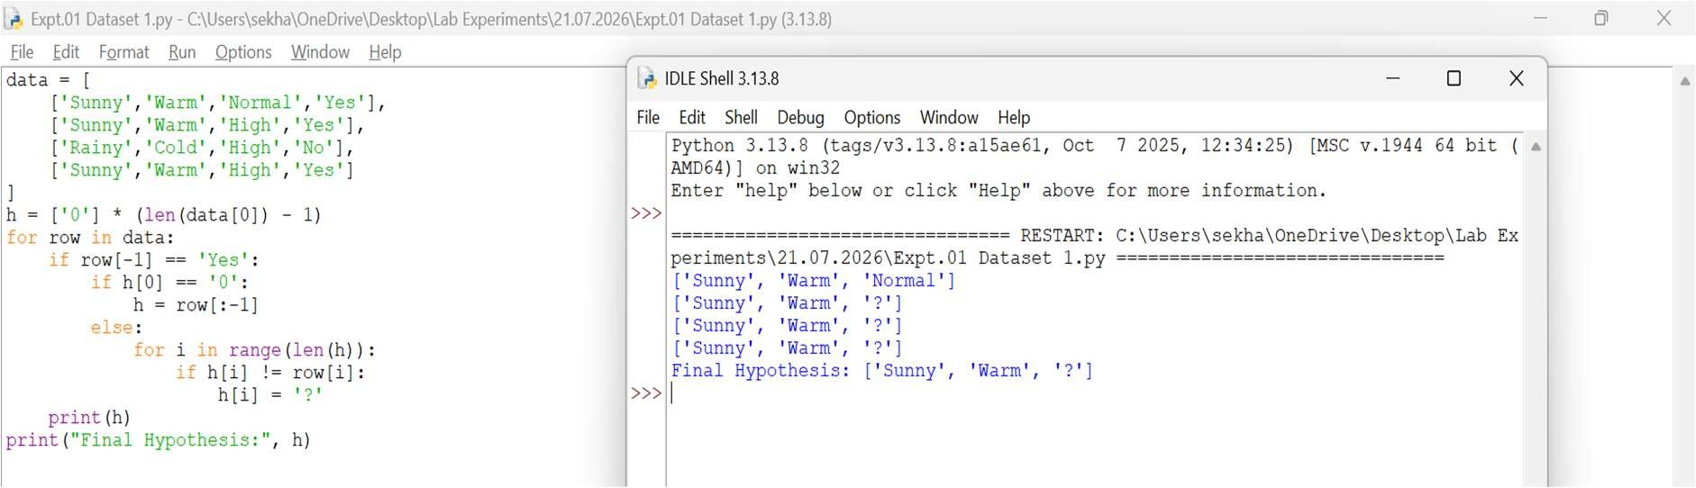

Dataset 2
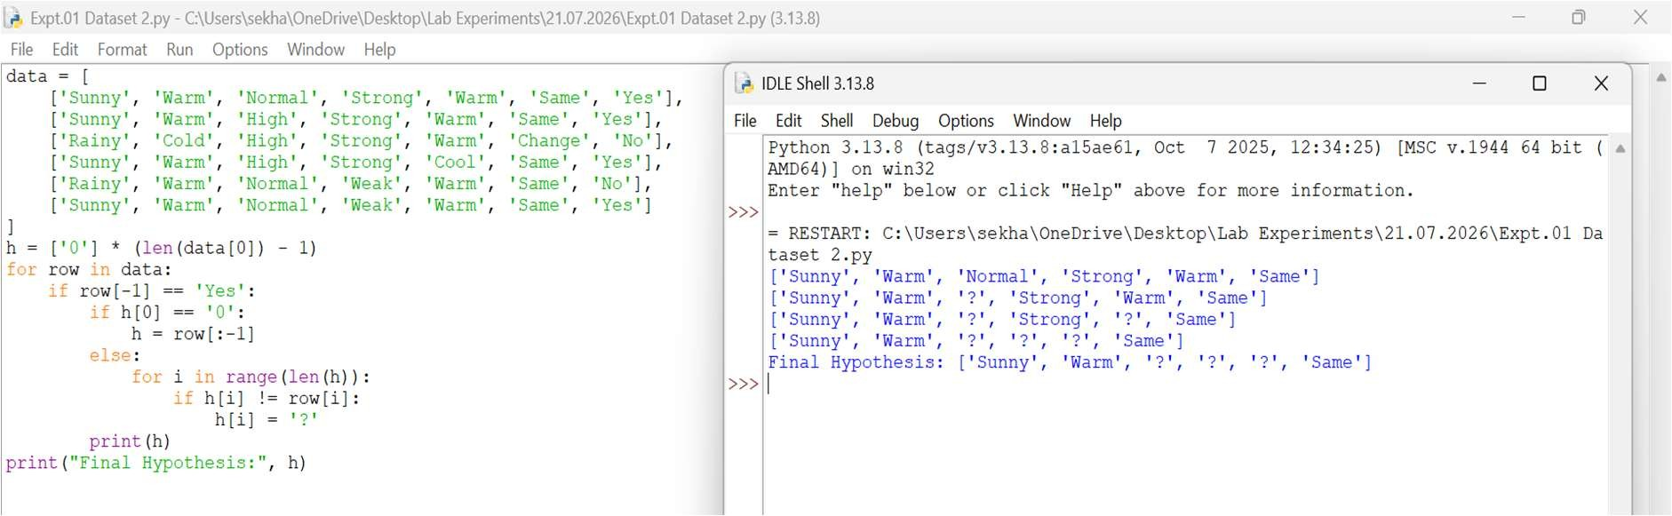
Dataset 3
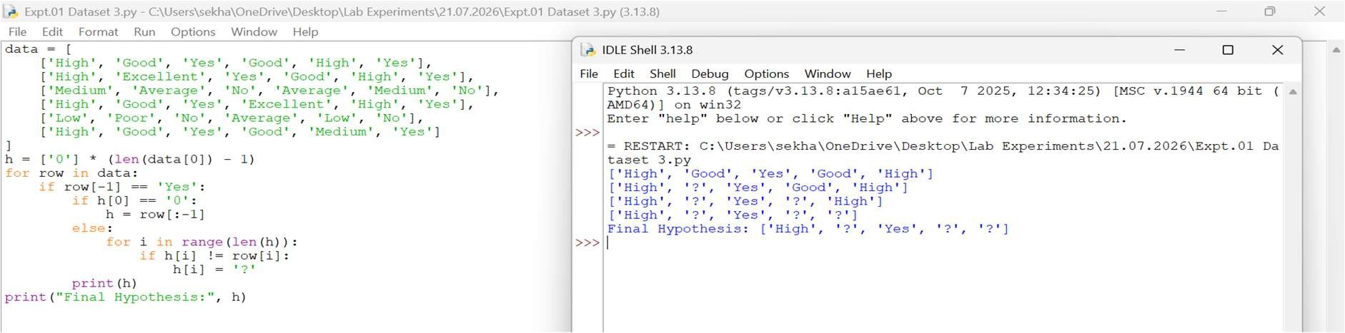
Dataset 4
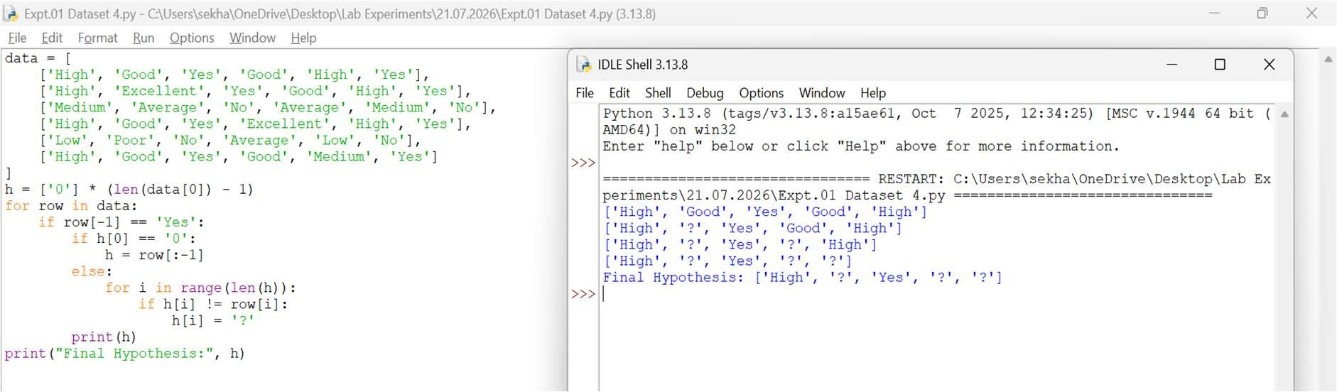

Dataset 5
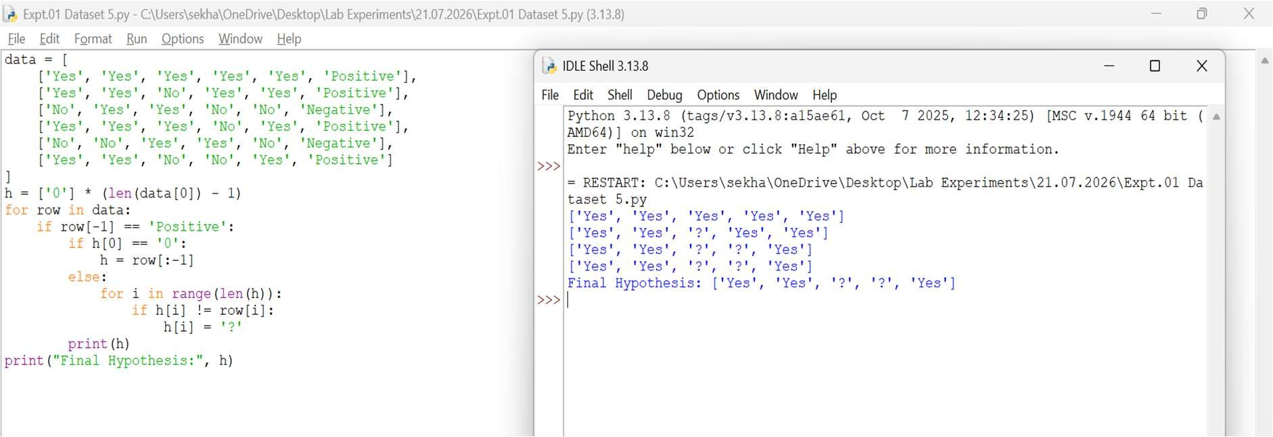
Dataset 6
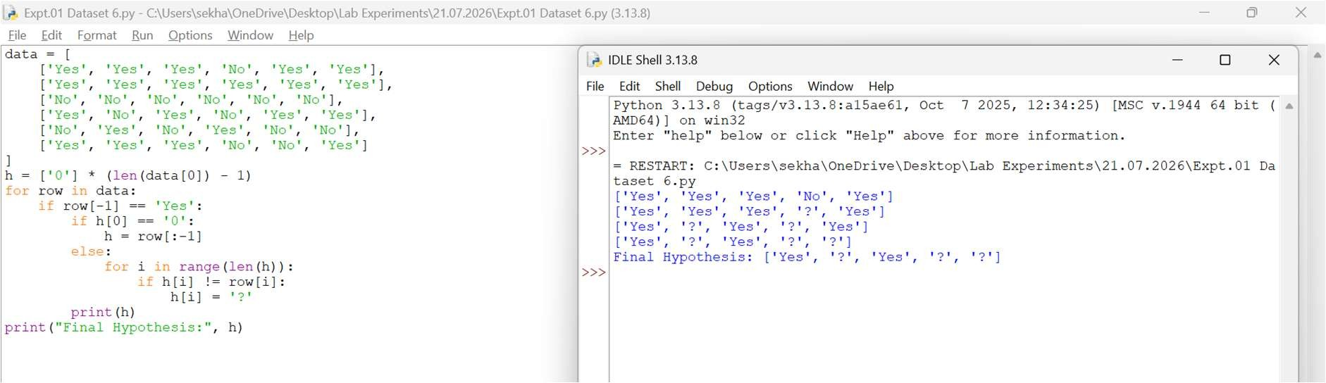
Result
Thus, the FIND-S algorithm was implemented successfully and the most specific hypothesis was obtained.

EXPERIMENT 2 – CANDIDATE ELIMINATION ALGORITHM
Aim
To implement and demonstrate the Candidate Elimination algorithm and obtain all hypotheses consistent with the training examples.
Procedure
- Define the training dataset.
- Initialize the Specific hypothesis (S).
- Initialize the General hypothesis (G).
- For positive examples, generalize S.
- For negative examples, specialize G.
- Update S and G after each iteration.
- Display the final hypotheses.
Code and Output
- Dataset 1
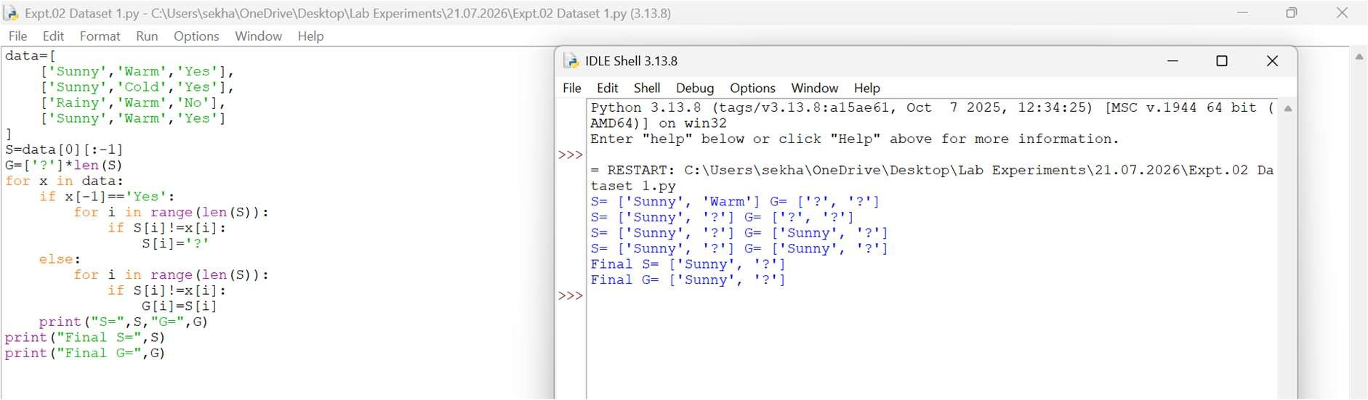
- Dataset 2
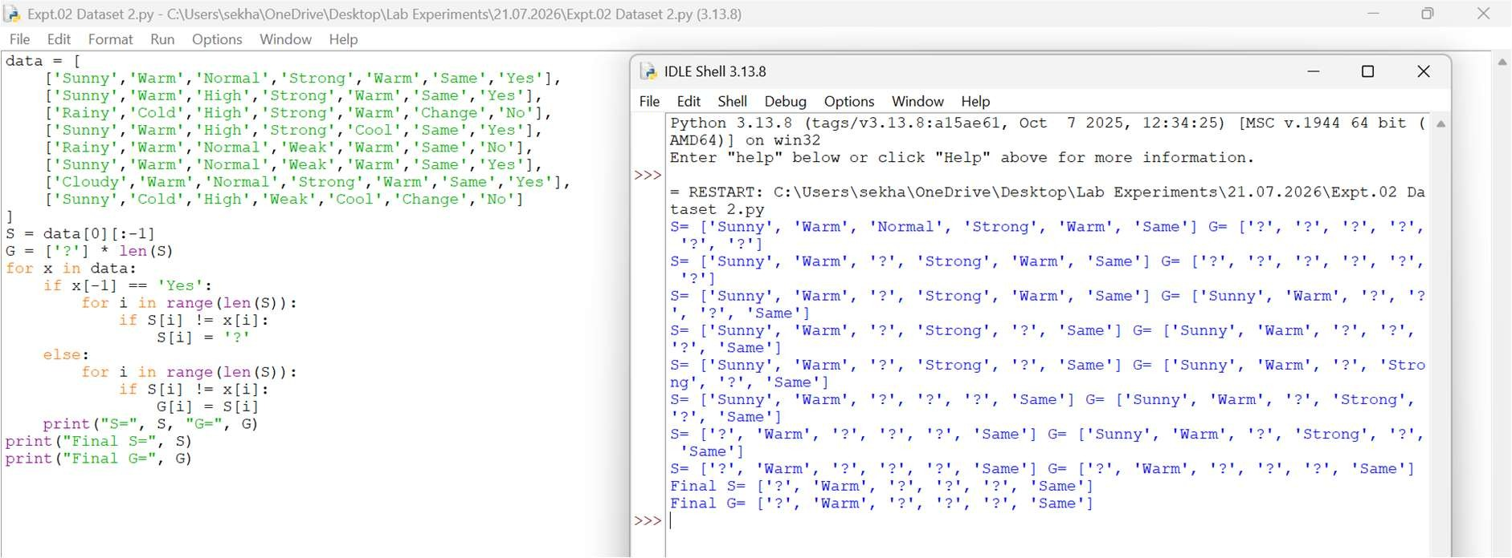
- Dataset 3
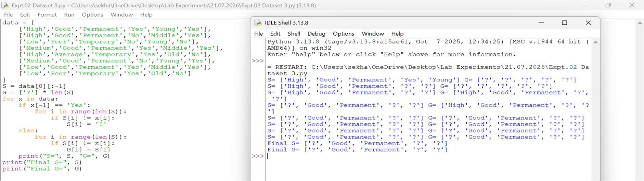
- Dataset 4
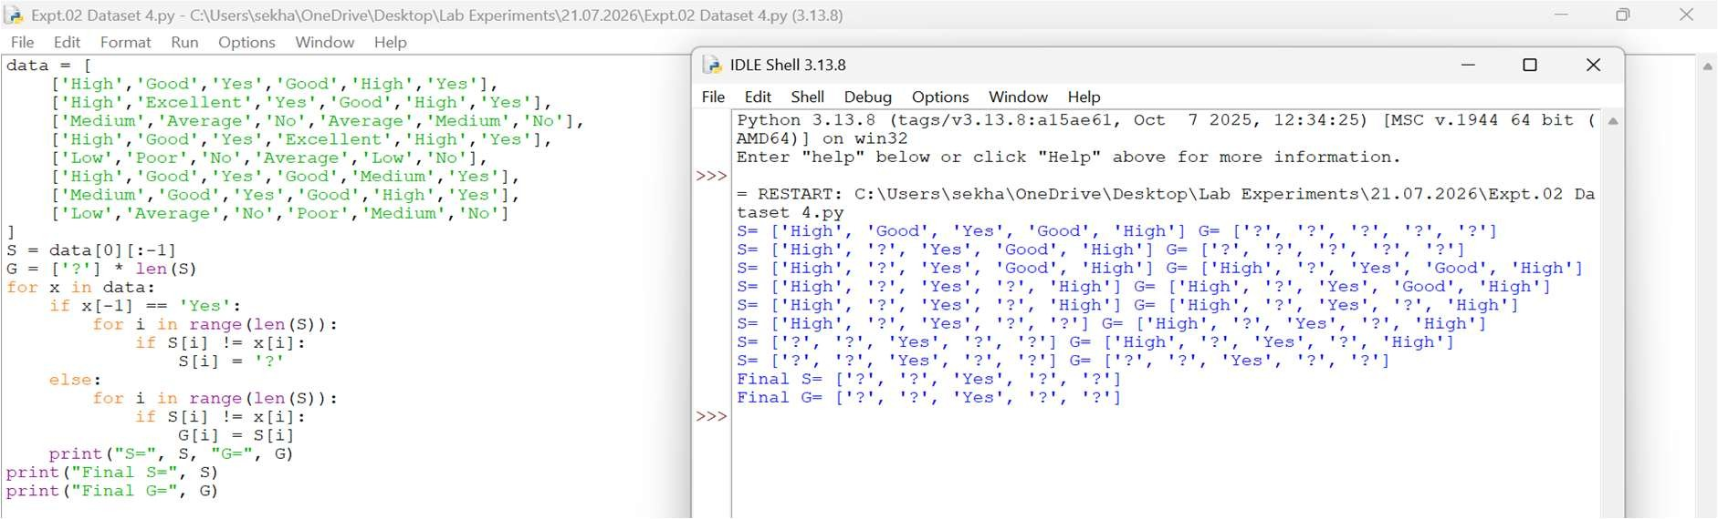
- Dataset 5
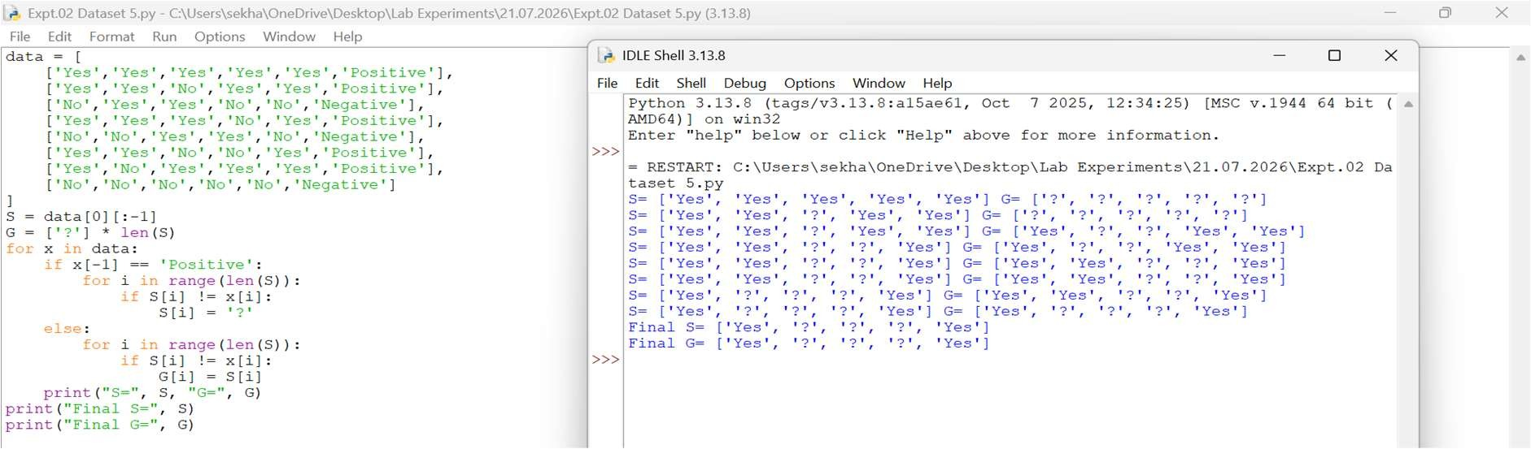
- Dataset 6
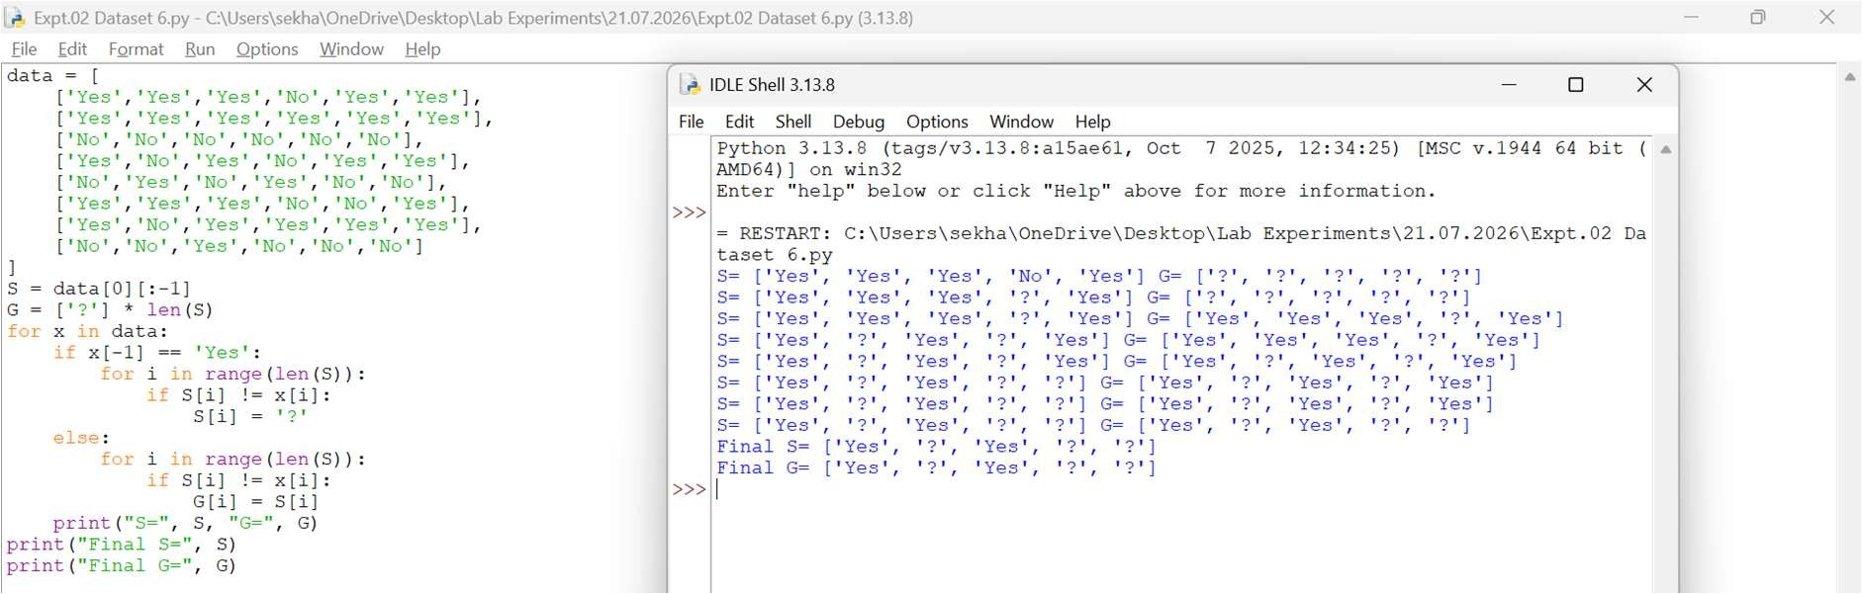
Result
Thus, the Candidate Elimination algorithm was implemented successfully and the final Specific and General hypotheses were obtained.

EXPERIMENT 3 – DECISION TREE (ID3) ALGORITHM
Aim
To implement and demonstrate the working of the Decision Tree based ID3 algorithm and classify a new sample.
Procedure
- Import the Decision Tree Classifier.
- Create the training dataset and target values.
- Create the Decision Tree model using entropy.
- Train the model using the training data.
- Classify a new sample using the trained model.
- Display the predicted result.
Code and Output
- Dataset 1
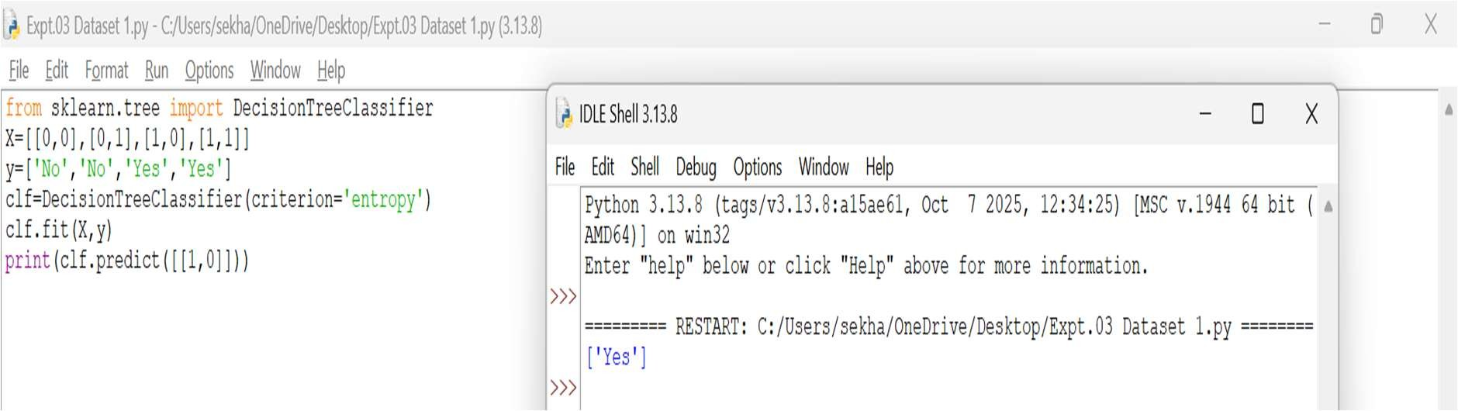
- Dataset 2
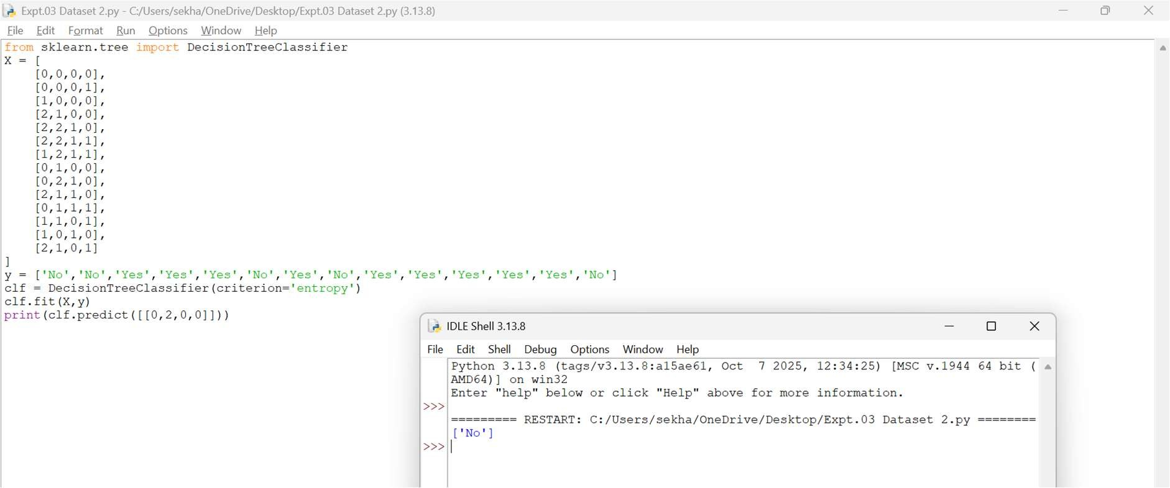
- Dataset 3

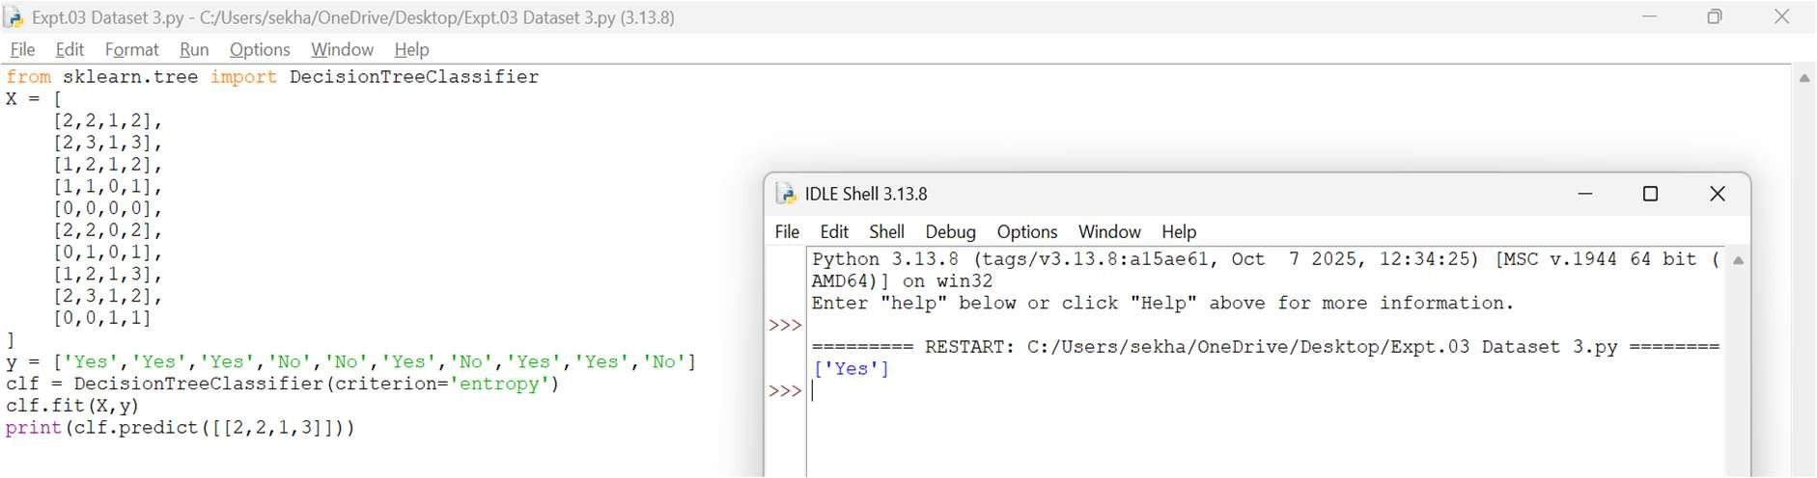
- Dataset 4
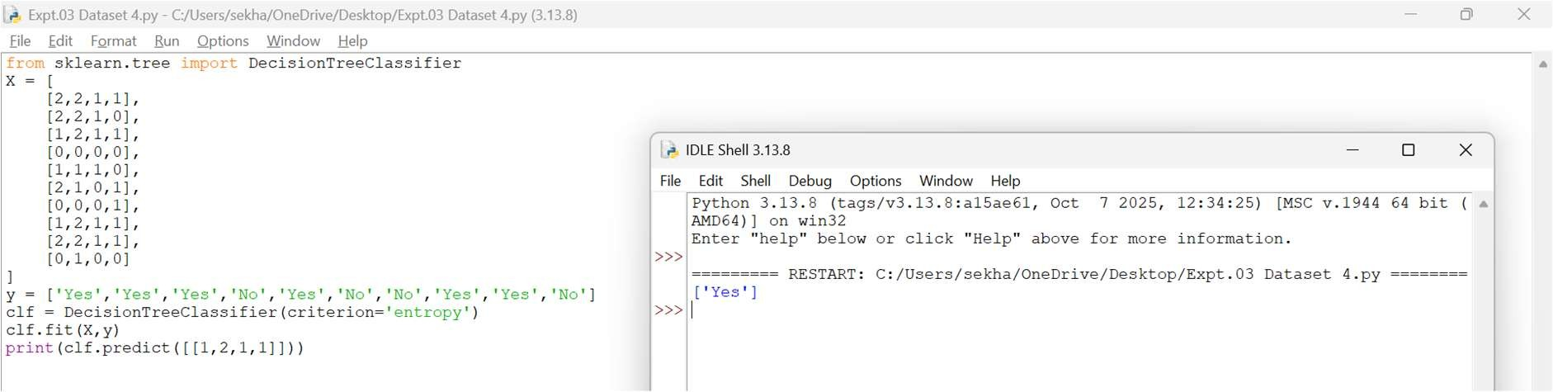
- Dataset 5
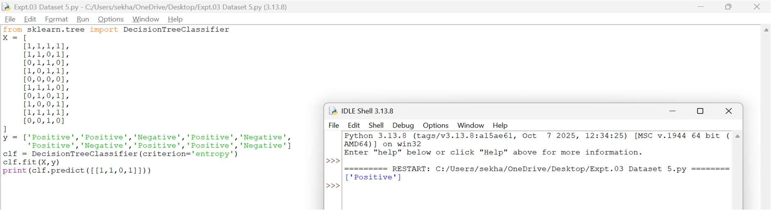
- Dataset 6
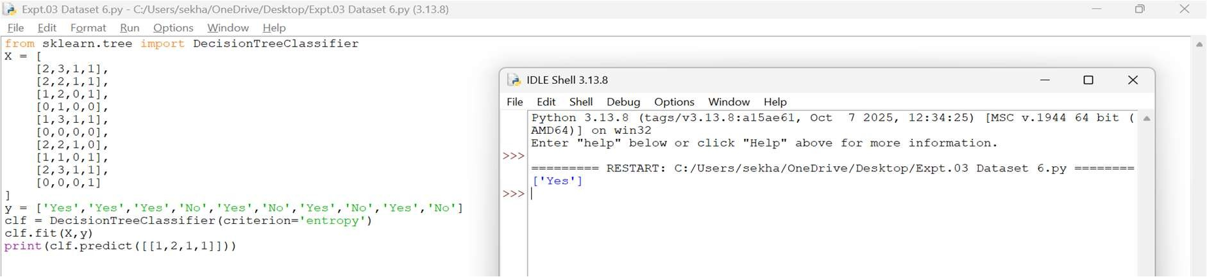
Result
Thus, the Decision Tree based ID3 algorithm was implemented successfully and the new sample was classified as 'Yes'.

EXPERIMENT 4 – ARTIFICIAL NEURAL NETWORK USING
BACKPROPAGATION
Aim
To build an Artificial Neural Network using the Backpropagation algorithm and classify a new sample.
Procedure
- Import the MLPClassifier.
- Create the training dataset and target values.
- Create the ANN model.
- Train the model using Backpropagation.
- Test the model using a new sample.
- Display the predicted result.
Code and Output
- Dataset 1
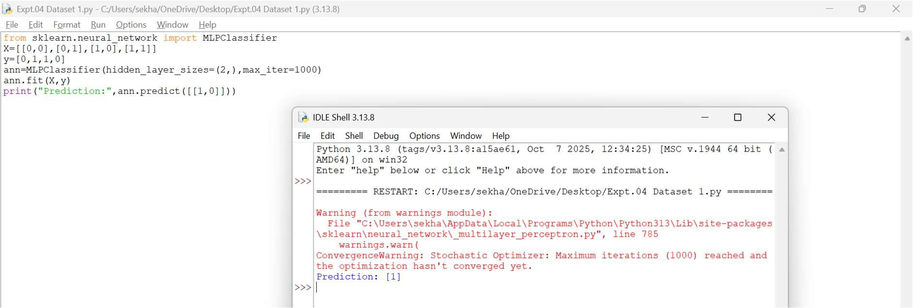
- Dataset 2
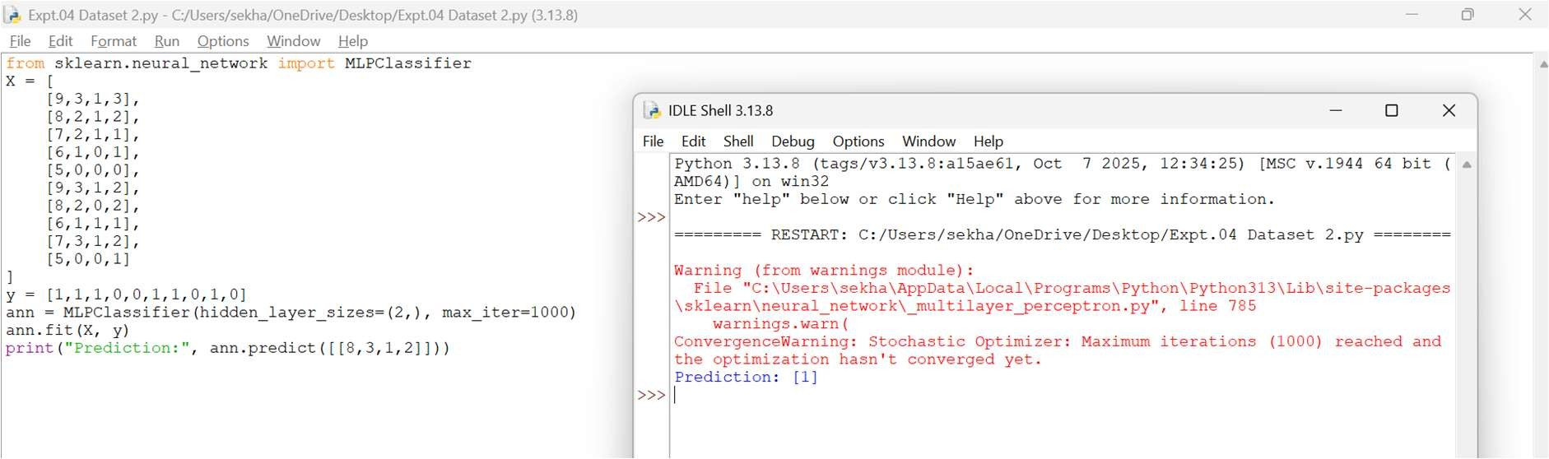
- Dataset 3
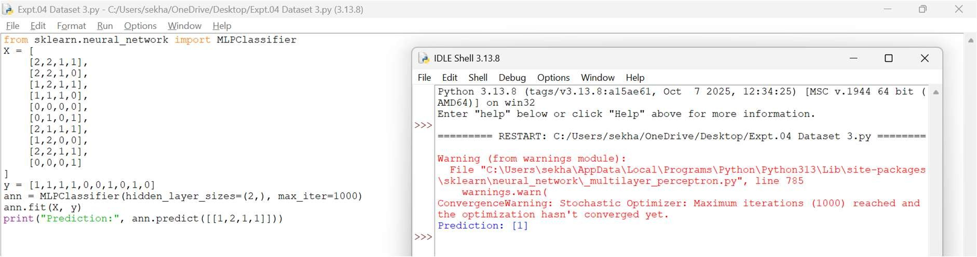
- Dataset 4
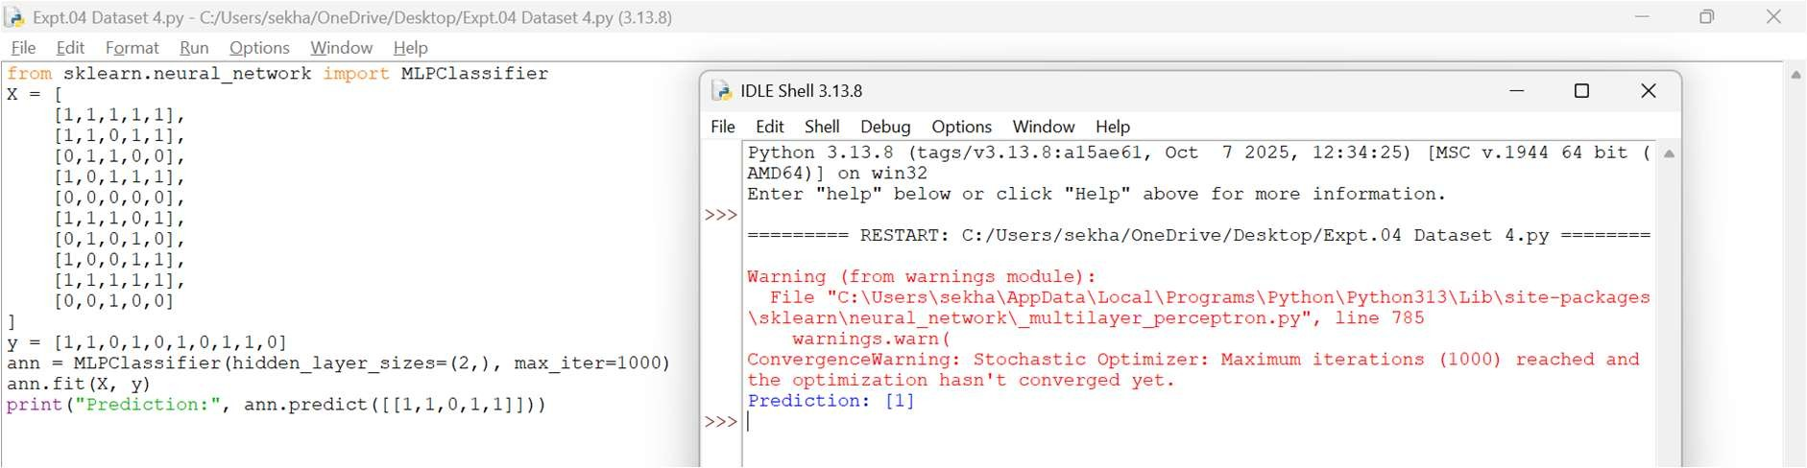
- Dataset 5
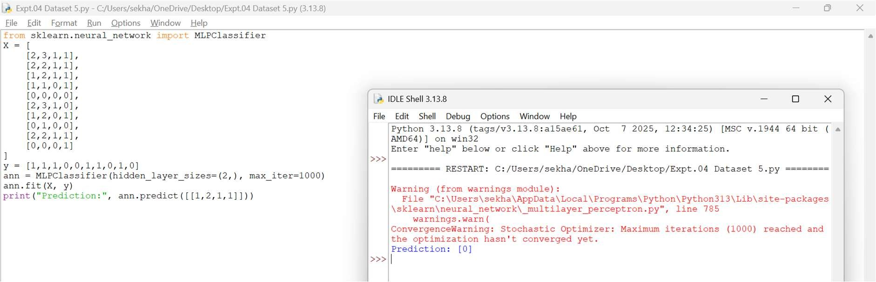
- Dataset 6
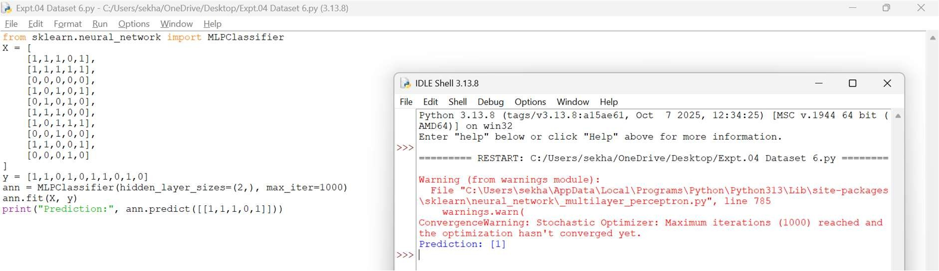
Result
Thus, the Artificial Neural Network using the Backpropagation algorithm was implemented successfully and the test sample was classified correctly.
EXPERIMENT 5 – K-NEAREST NEIGHBOURS (K-NN)
Aim
To implement the K-Nearest Neighbours (K-NN) algorithm in Python and classify a new sample.
Procedure
- Import the KNeighborsClassifier.
- Create the training dataset and class labels.
- Create the K-NN model with K = 3.
- Train the model using the training data.
- Predict the class of a new sample.
- Display the predicted result.
Code and Output
- Dataset 1
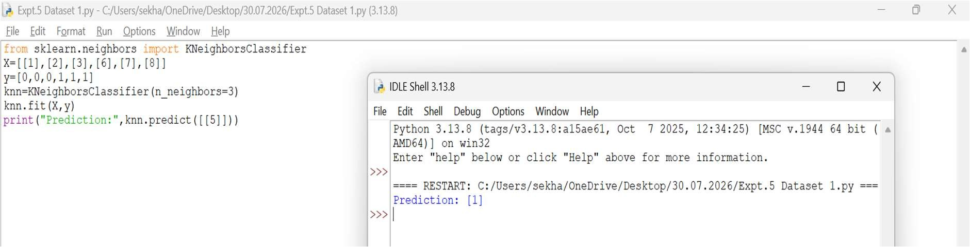
- Dataset 2
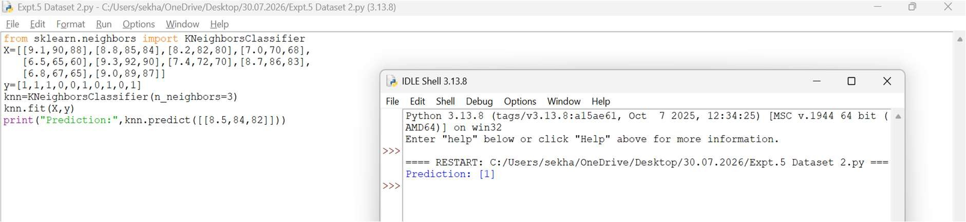
- Dataset 3
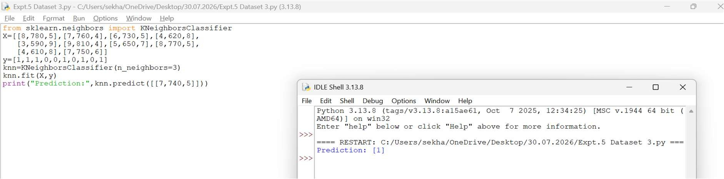
- Dataset 4
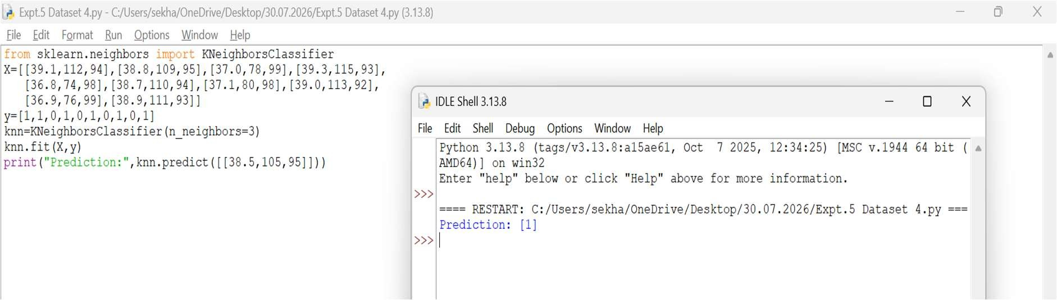
- Dataset 5
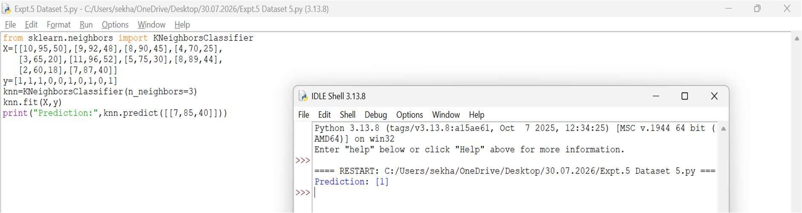
- Dataset 6
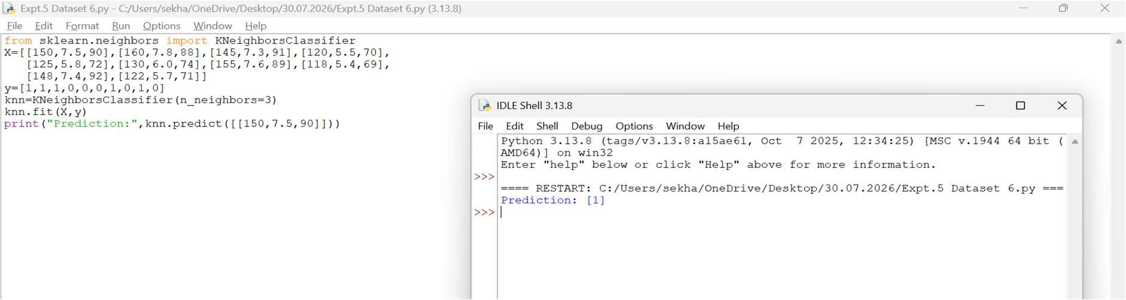
Result
Thus, the K-Nearest Neighbours (K-NN) algorithm was implemented successfully and the test sample was classified as Class 1.

EXPERIMENT 6 – NAÏVE BAYES CLASSIFIER
Aim
To implement the Naïve Bayes algorithm and evaluate its performance using confusion matrix and accuracy.
Procedure
- Import GaussianNB, confusion matrix, and accuracy score.
- Create the dataset and class labels.
- Train the Naïve Bayes model.
- Predict the class labels.
- Calculate the confusion matrix and accuracy.
- Display the results.
Code and Output
- Dataset 1
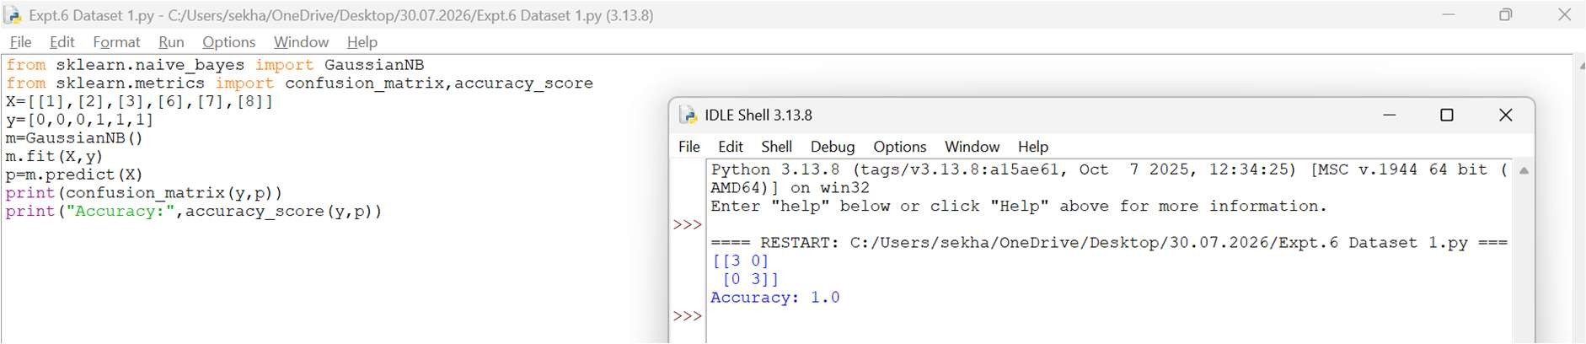
- Dataset 2
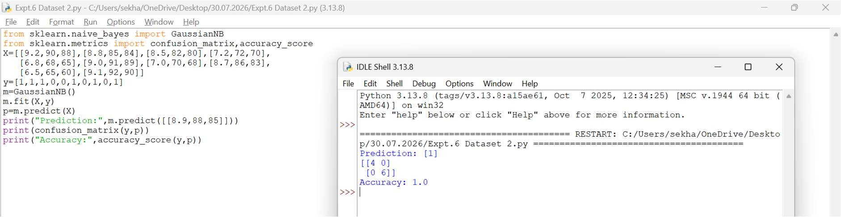
- Dataset 3
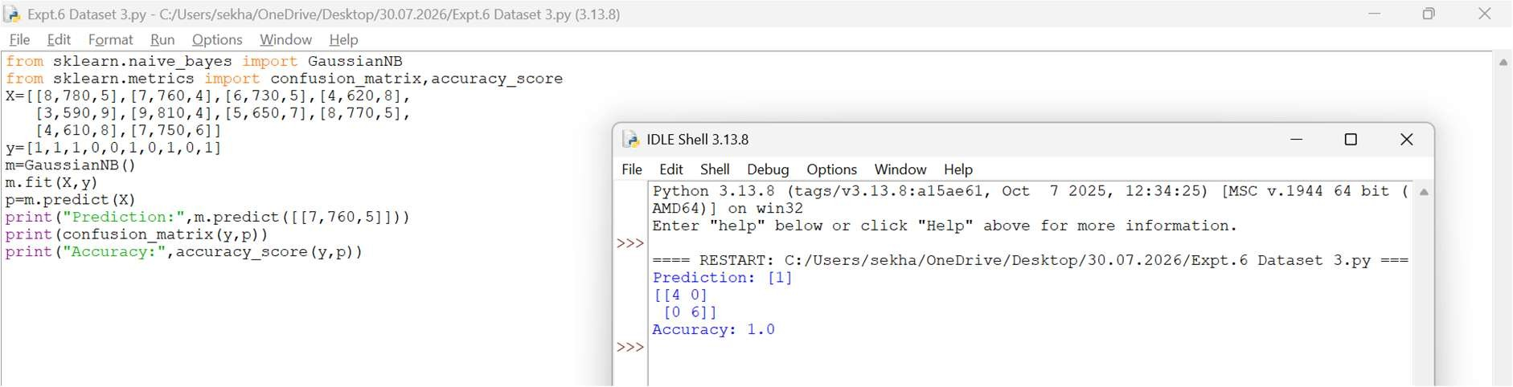
- Dataset 4
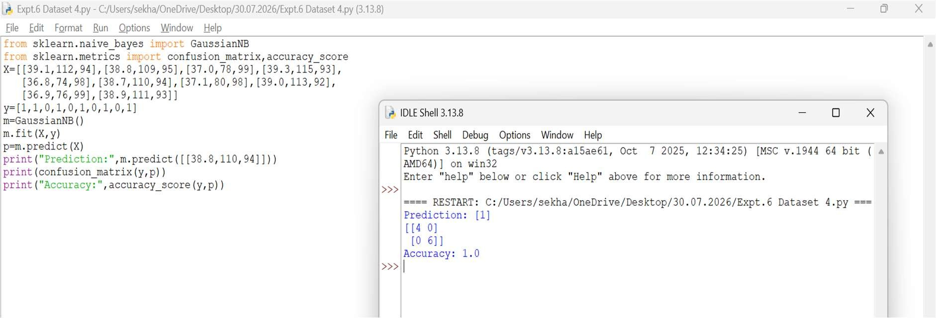
- Dataset 5
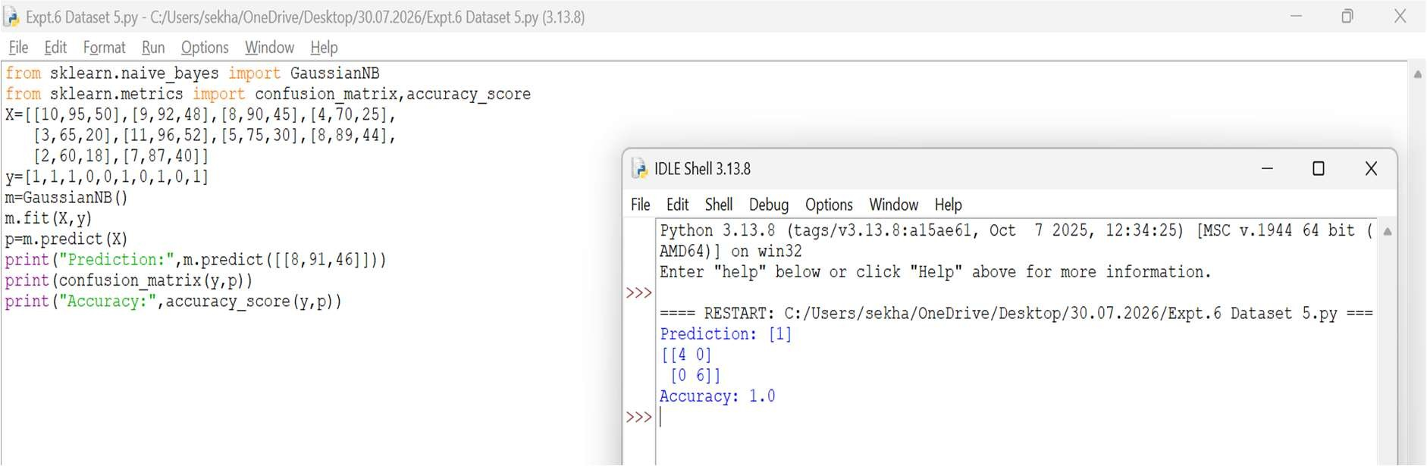
- Dataset 6
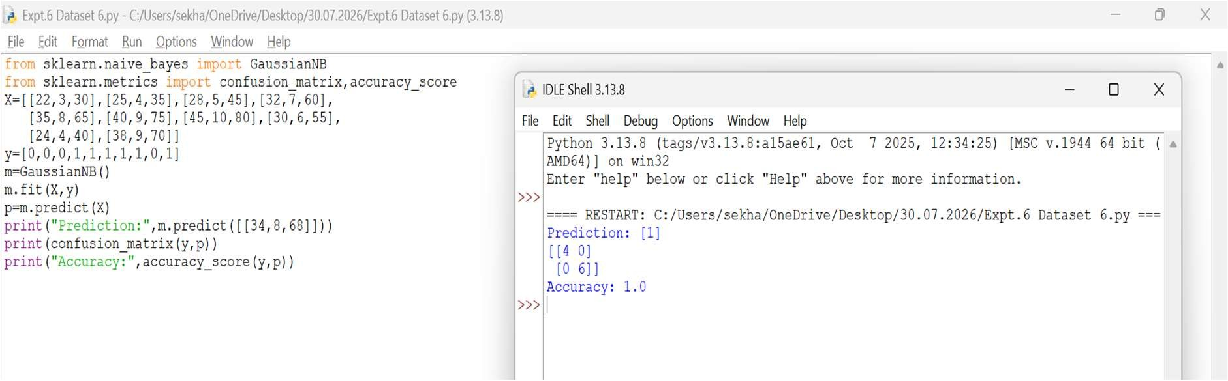
Result
Thus, the Naïve Bayes classifier was implemented successfully and achieved 100% accuracy on the given dataset.

EXPERIMENT 7 – LOGISTIC REGRESSION
Aim
To implement Logistic Regression for binary classification.
Procedure
- Import the Logistic Regression model.
- Create the dataset and class labels.
- Train the model using the training data.
- Predict the class of a new sample.
- Display the predicted result.
Code and Output
- Dataset 1
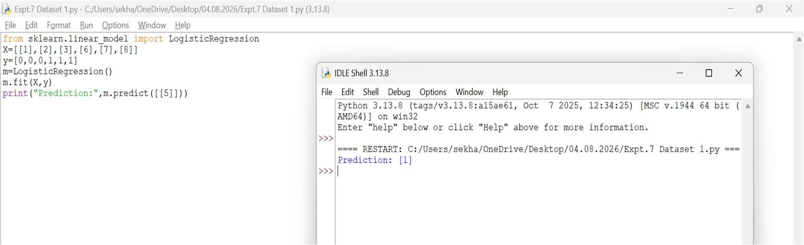
- Dataset 2
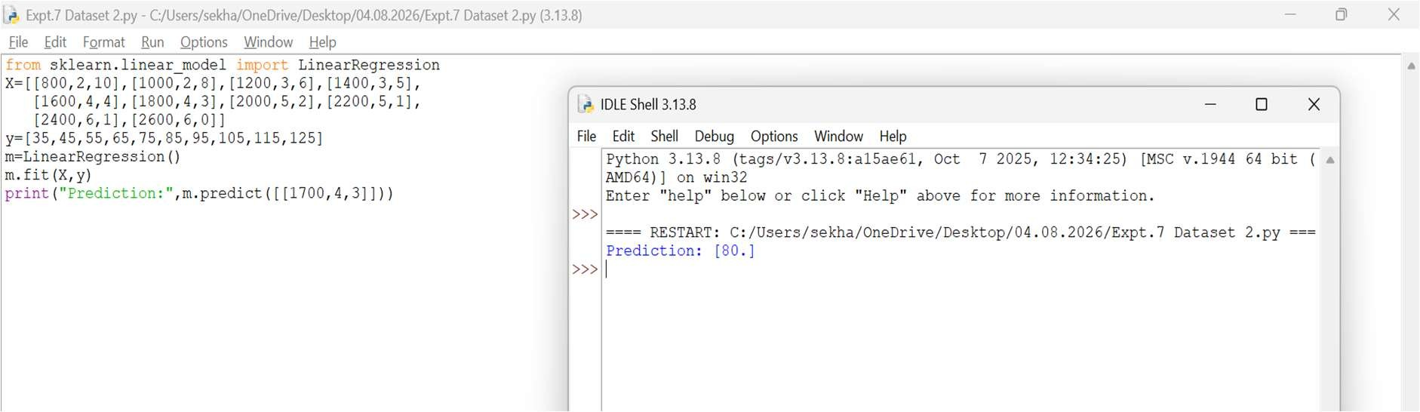
- Dataset 3
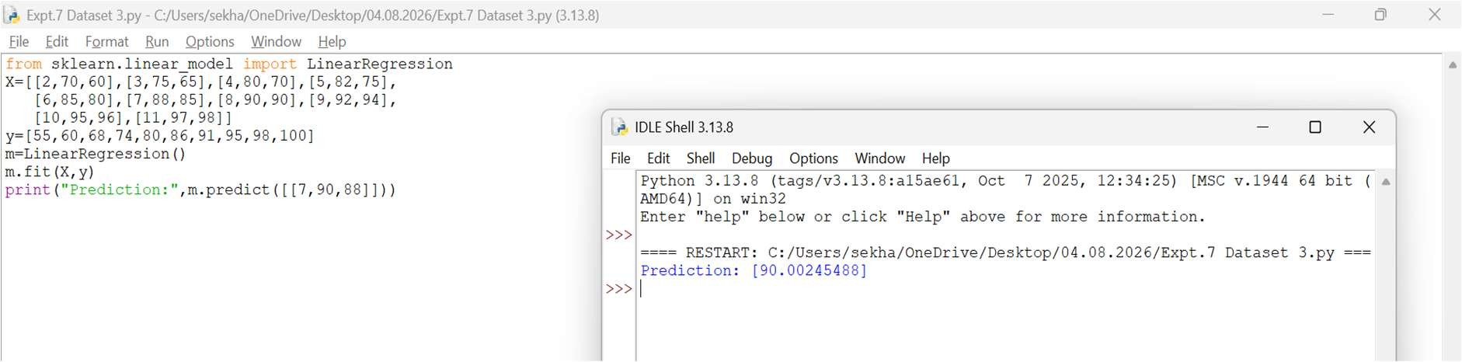
- Dataset 4
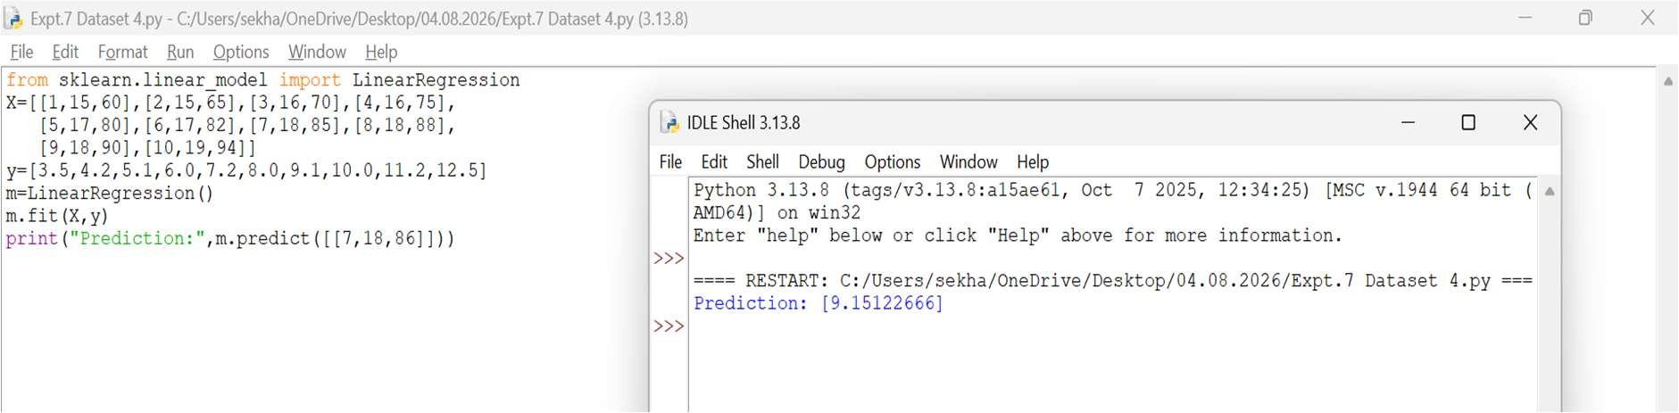
- Dataset 5
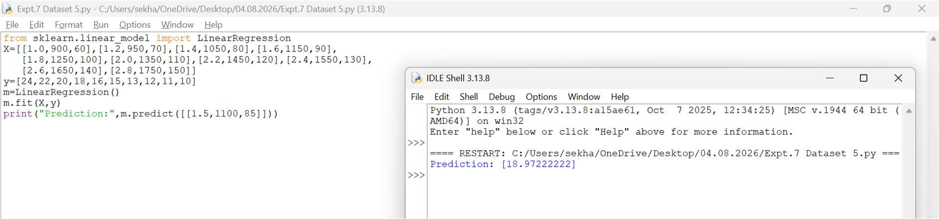
- Dataset 6
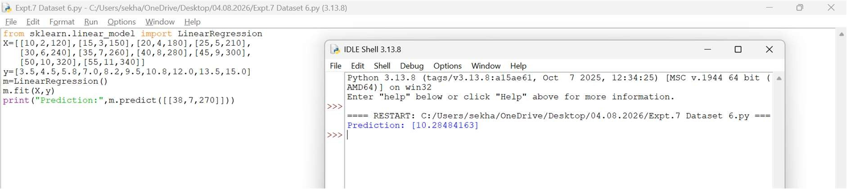
Result
Thus, the Logistic Regression model was implemented successfully and the test sample was classified as Class 1.

EXPERIMENT 8 – LINEAR REGRESSION
Aim
To implement Linear Regression for prediction.
Procedure
- Import the Linear Regression model.
- Create the dataset and target values.
- Train the model using the training data.
- Predict a new value.
- Display the predicted result.
Code and Output
- Dataset 1
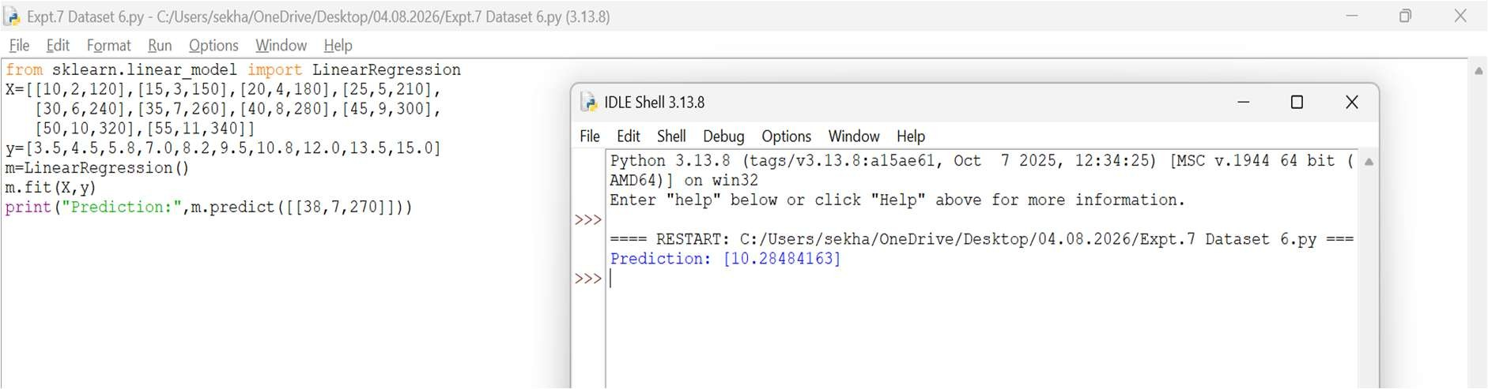
- Dataset 2
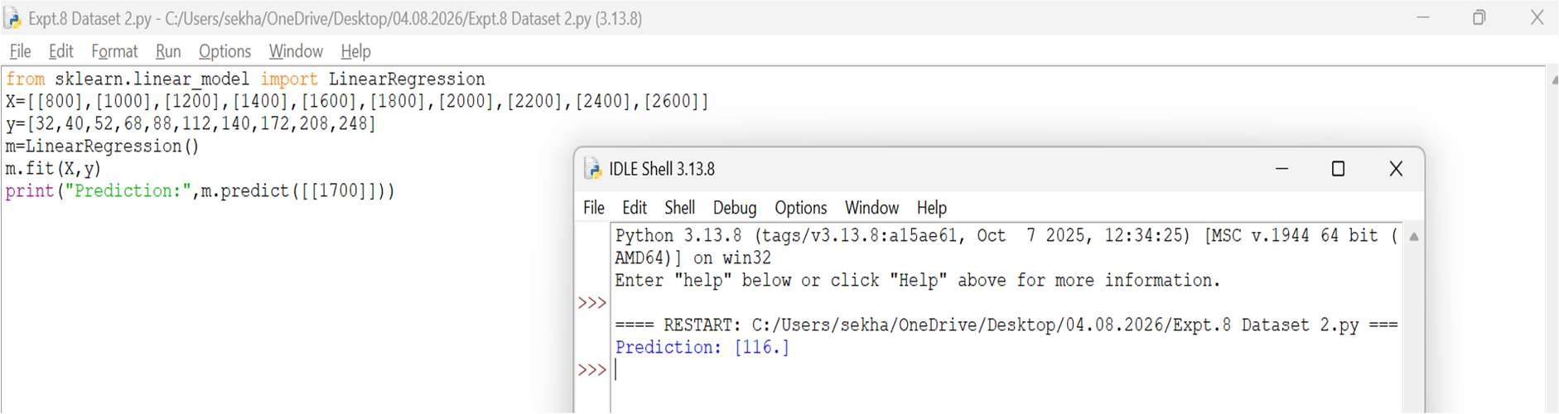
- Dataset 3
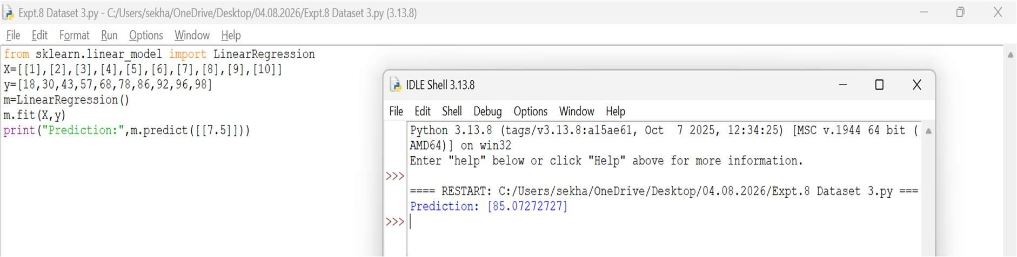
- Dataset 4
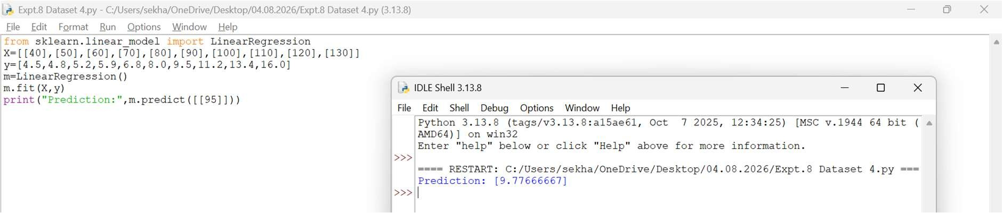
- Dataset 5
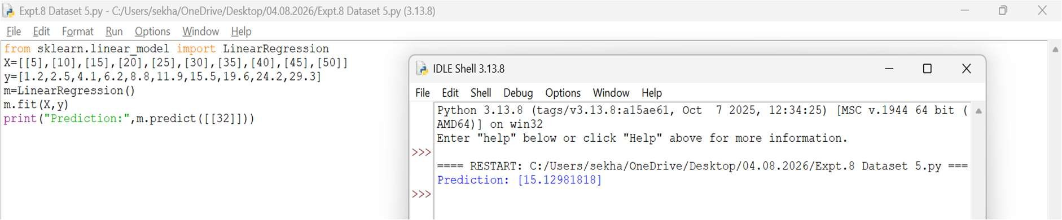
- Dataset 6
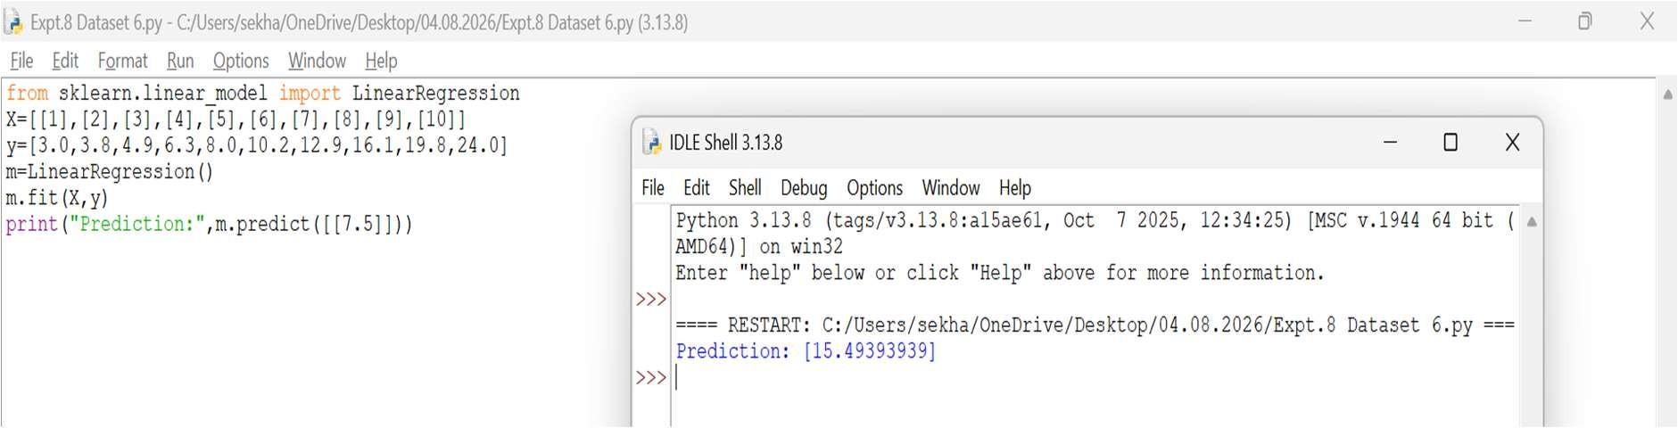
Result
Thus, the Linear Regression model was implemented successfully and the predicted value obtained was 12.

EXPERIMENT 9 – COMPARISON OF LINEAR AND POLYNOMIAL REGRESSION
AIM: To compare Linear Regression and Polynomial Regression using Python.
Procedure
- Import Linear Regression and Polynomial Features.
- Create the dataset.
- Apply Linear Regression and predict values.
- Transform the data using Polynomial Features.
- Apply Polynomial Regression and predict values.
- Compare the results.
Code and Output
- Dataset 1
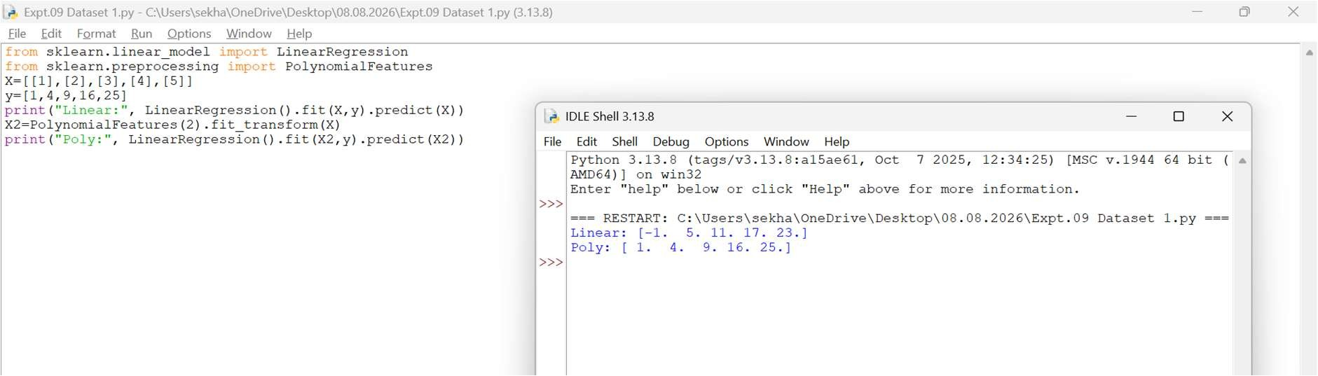
- Dataset 2
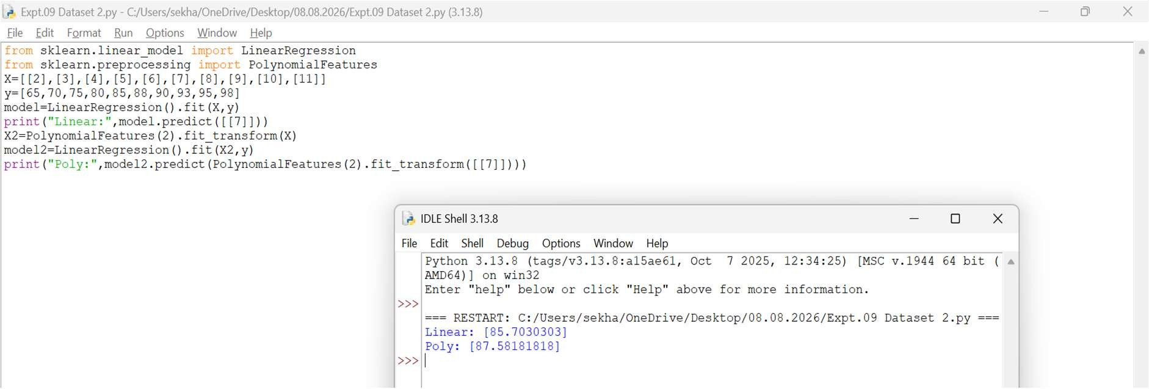
- Dataset 3
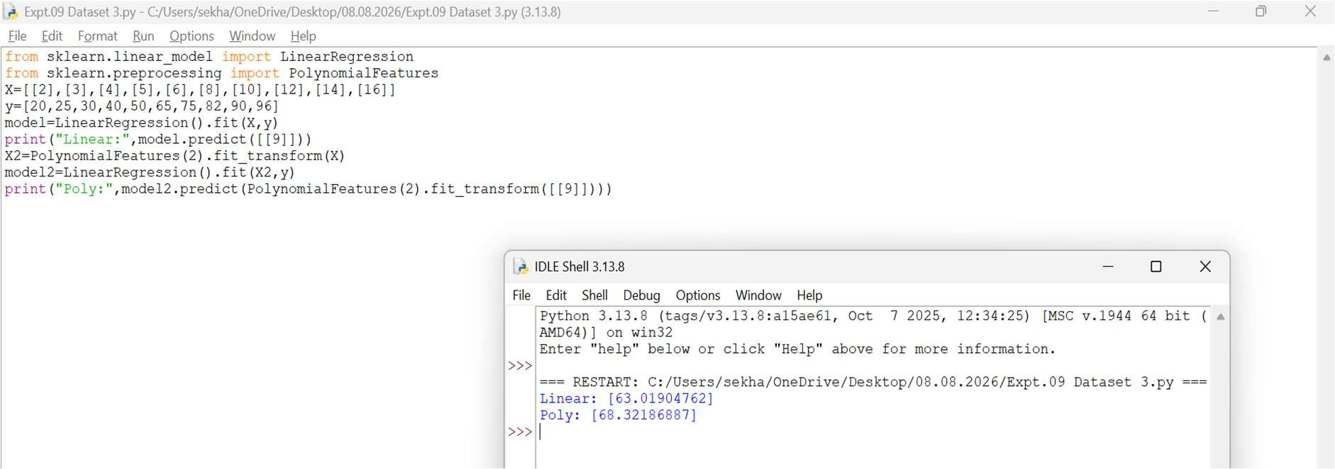
- Dataset 4
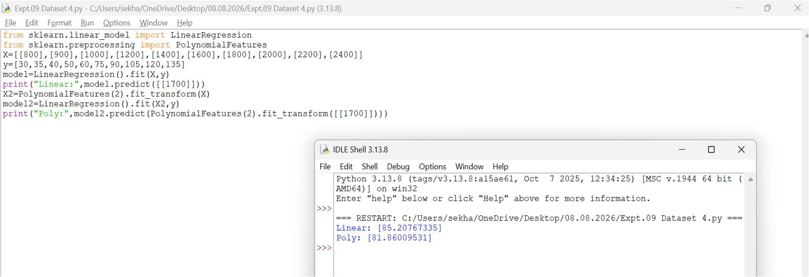
- Dataset 5
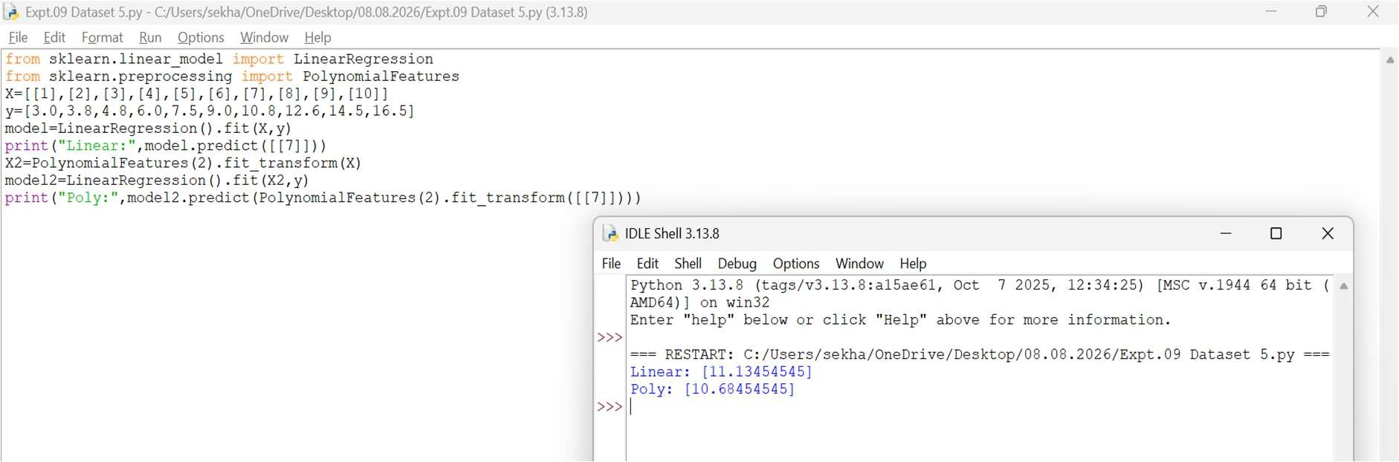
- Dataset 6
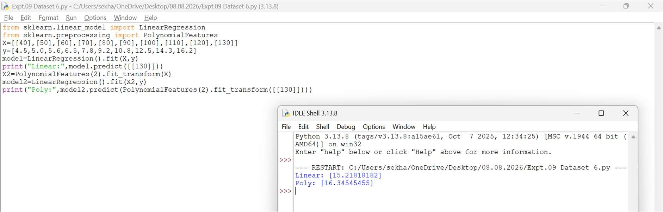
Result
Thus, Linear Regression and Polynomial Regression were implemented successfully.
Polynomial Regression produced more accurate results for nonlinear data.

EXPERIMENT 10 – EXPECTATION MAXIMIZATION (EM) ALGORITHM
Aim
To implement the Expectation Maximization (EM) algorithm for clustering data.
Procedure
- Import the Gaussian Mixture Model.
- Create the dataset.
- Train the EM model.
- Predict the cluster labels.
- Display the clustering result.
Code and Output
- Dataset 1
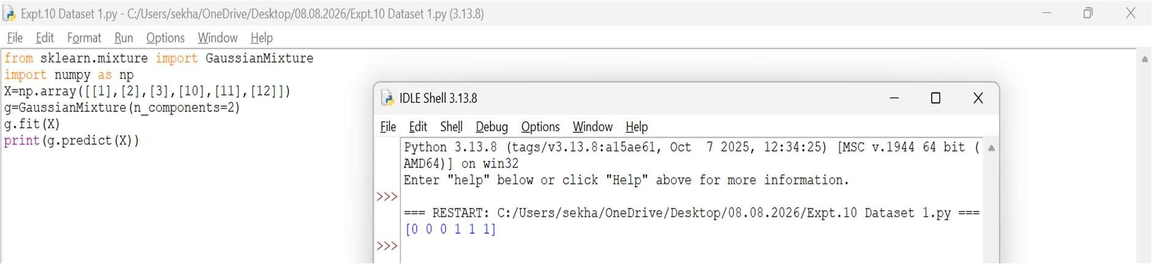
- Dataset 2
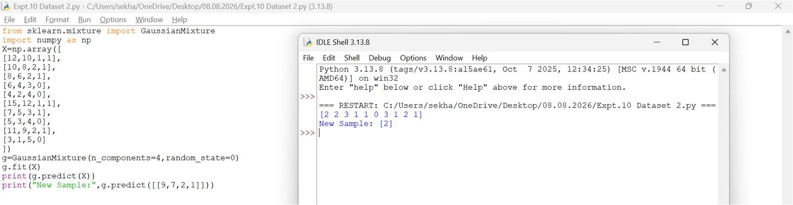
- Dataset 3
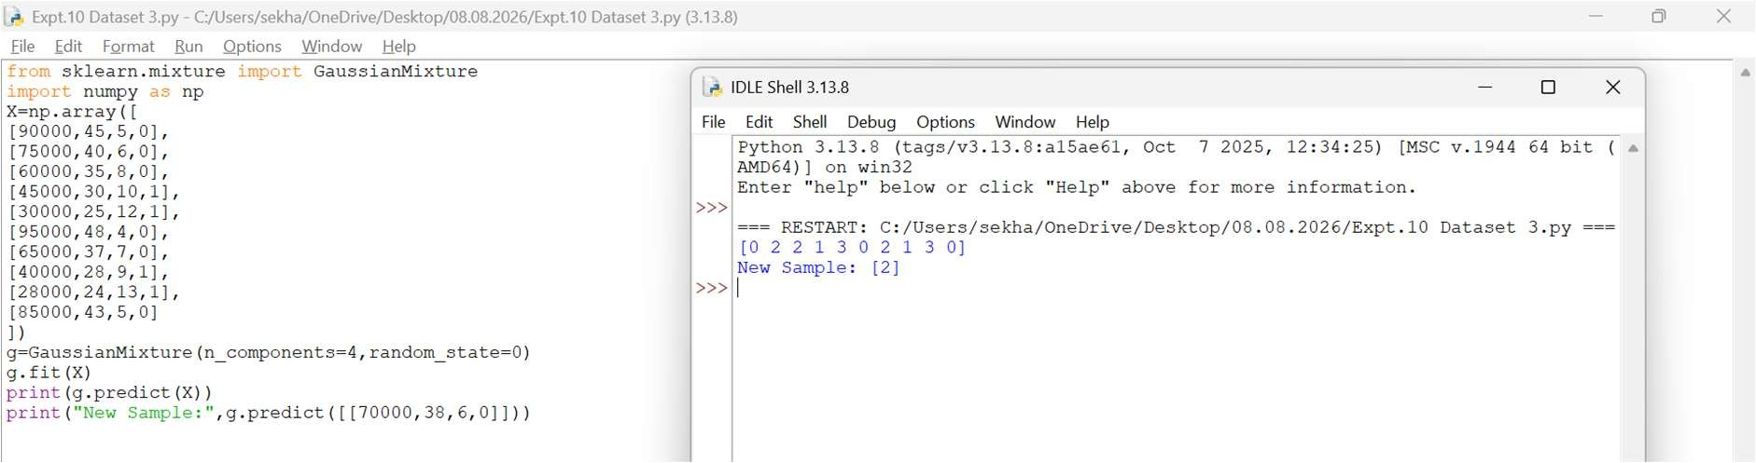
- Dataset 4
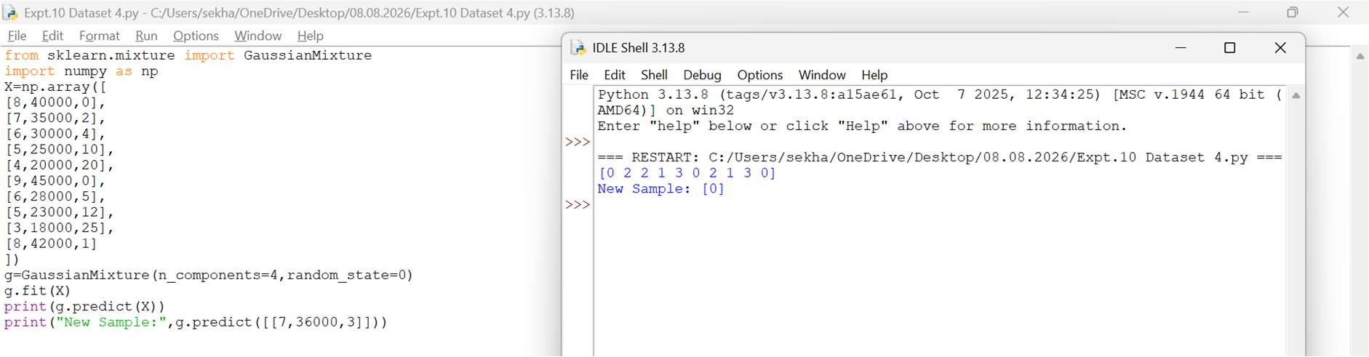
- Dataset 5
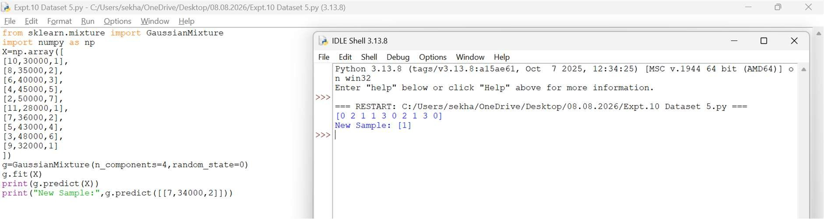
- Dataset 6
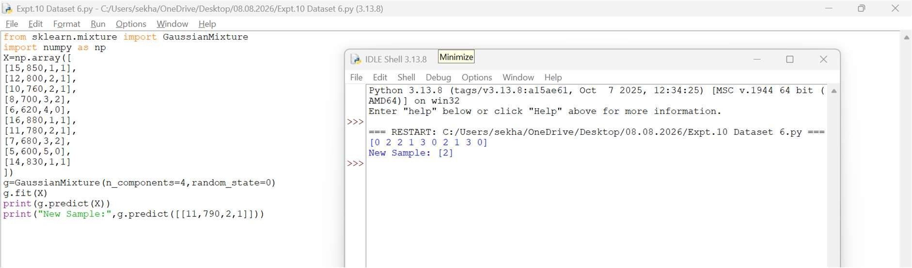
Result
Thus, the Expectation Maximization (EM) algorithm was implemented successfully and the data points were grouped into clusters.

EXPERIMENT 11 – CREDIT SCORE CLASSIFICATION
Aim
To classify credit scores using the Decision Tree algorithm.
Procedure
- Import the Decision Tree Classifier.
- Create the dataset and class labels.
- Train the model using the training data.
- Predict the credit score category.
- Display the predicted result.
Code and Output
- Dataset 1
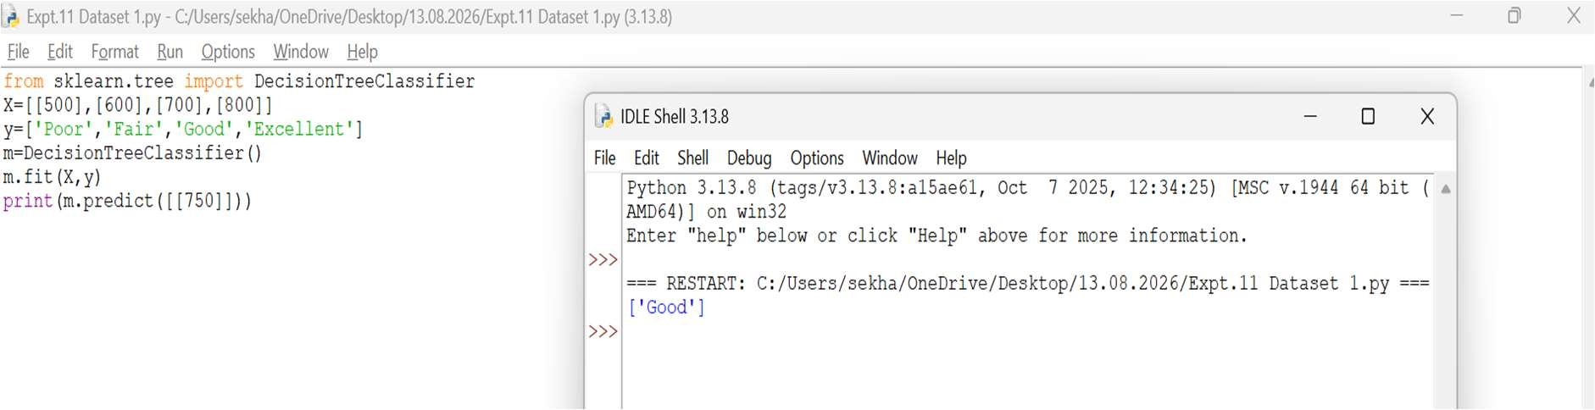
- Dataset 2
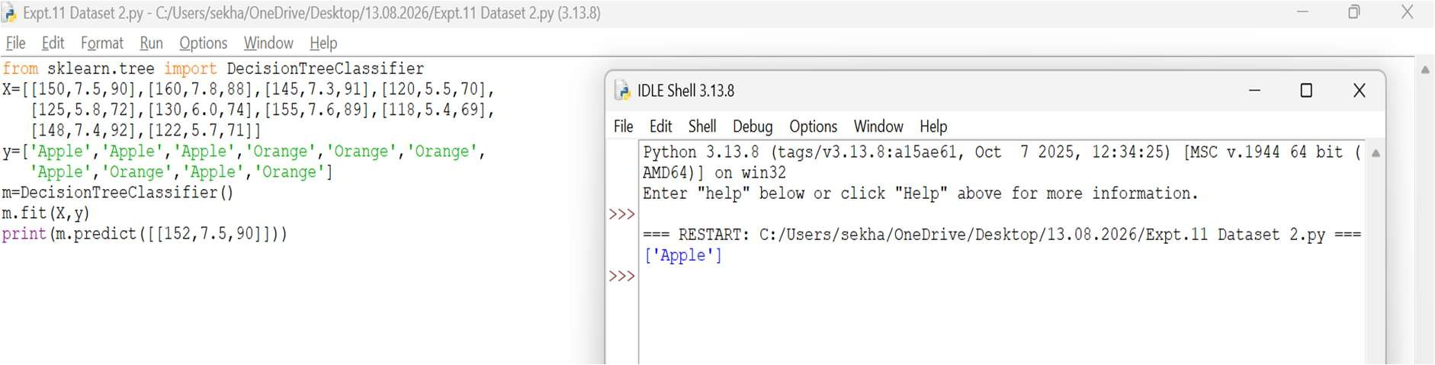
- Dataset 3
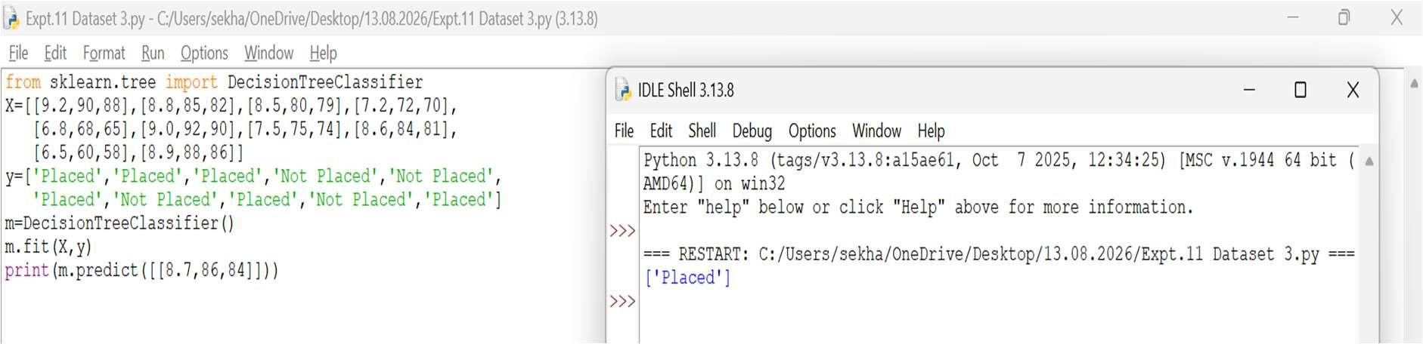
- Dataset 4
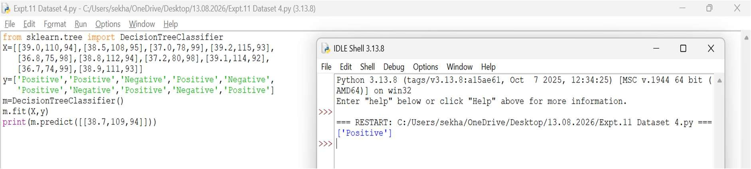
- Dataset 5
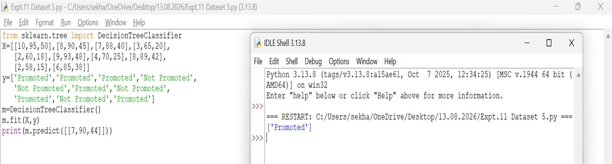
- Dataset 6
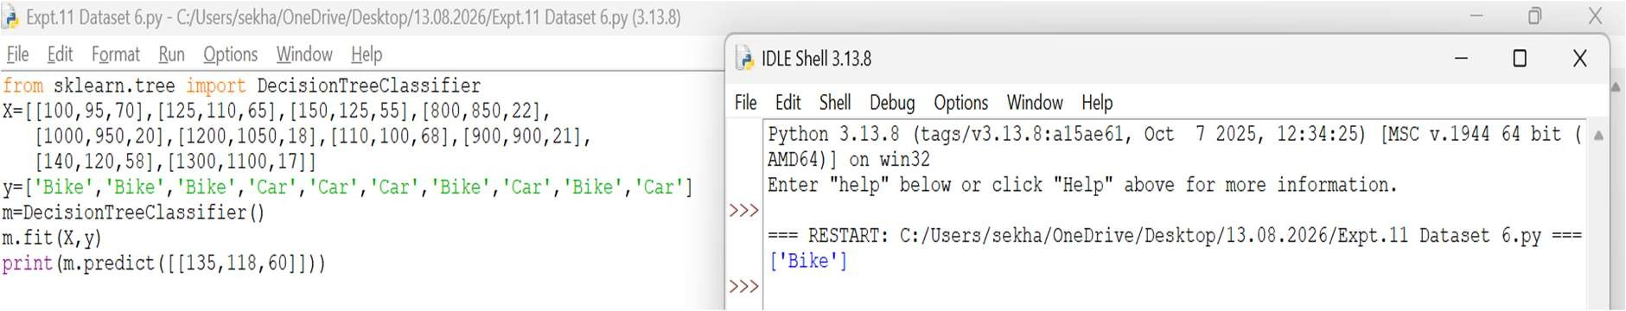
Result
Thus, the Decision Tree classifier was implemented successfully and the credit score was classified as Good.

EXPERIMENT 12 – IRIS FLOWER CLASSIFICATION USING KNN
Aim
To classify Iris flowers using the K-Nearest Neighbours (KNN) algorithm.
Procedure
- Import the Iris dataset and KNN classifier.
- Load the Iris dataset.
- Train the KNN model using the training data.
- Predict the flower class.
- Display the predicted result.
Code and Output

- Dataset 1
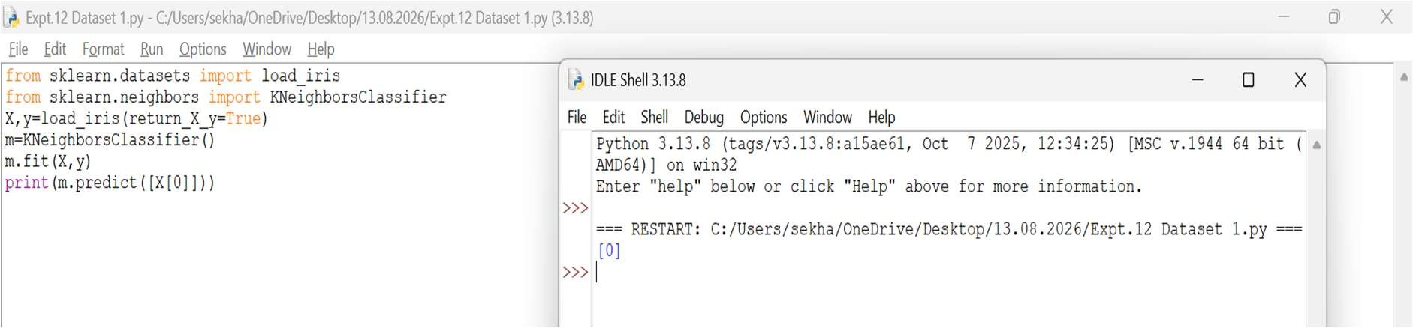
- Dataset 2
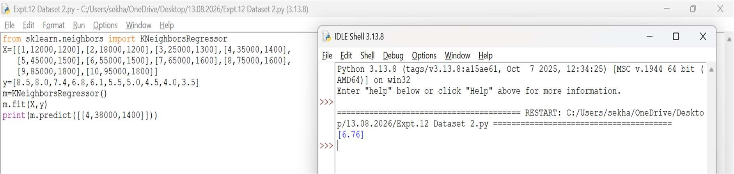
- Dataset 3
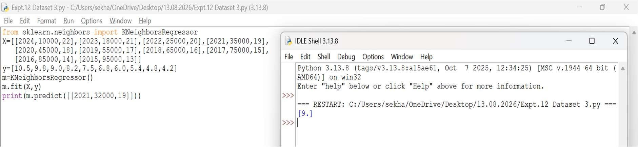
- Dataset 4
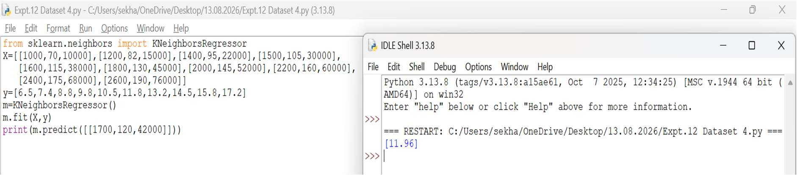
- Dataset 5
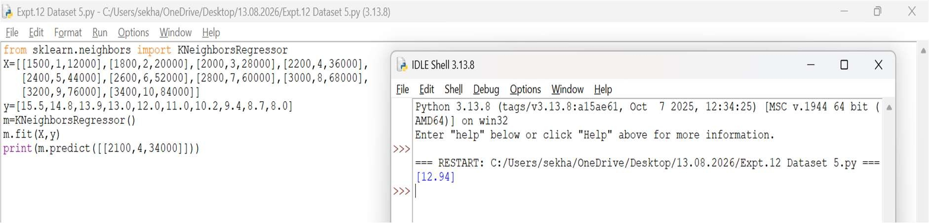
- Dataset 6
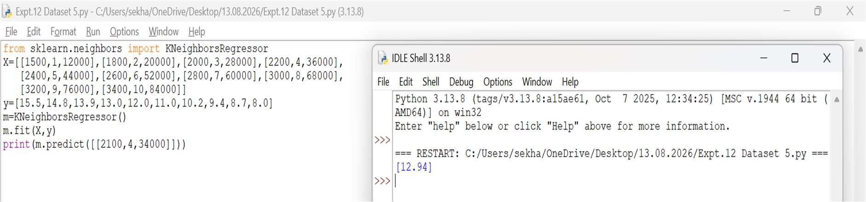
Result
Thus, the Iris flower was classified successfully using the K-Nearest Neighbours (KNN) algorithm.
EXPERIMENT 13 – CAR PRICE PREDICTION
Aim
To predict car prices using the Linear Regression algorithm.
Procedure
- Import the Linear Regression model.
- Create the dataset and target values.
- Train the model using the training data.
- Predict the car price for a new input.
- Display the predicted result.
Code and Output
  - Dataset 1
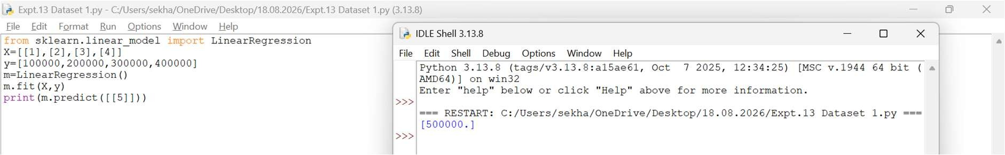
  - Dataset 2
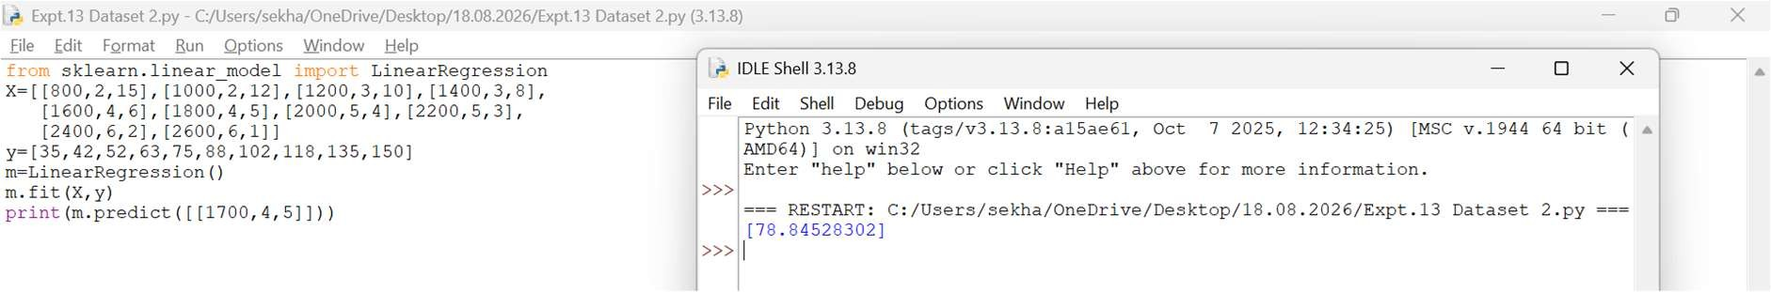
  - Dataset 3
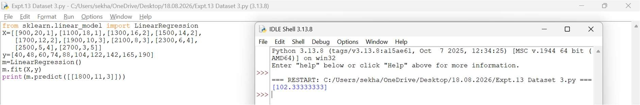
  - Dataset 4
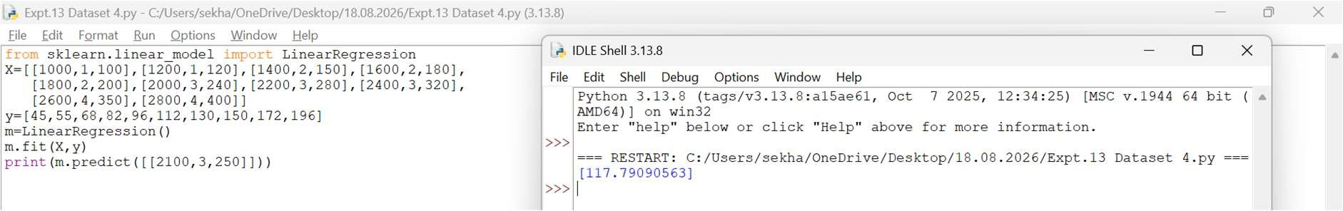
  - Dataset 5
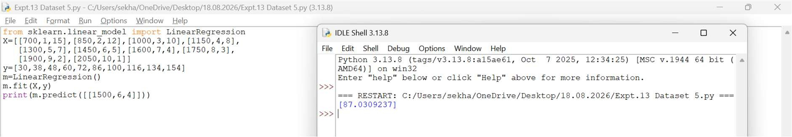
  - Dataset 6
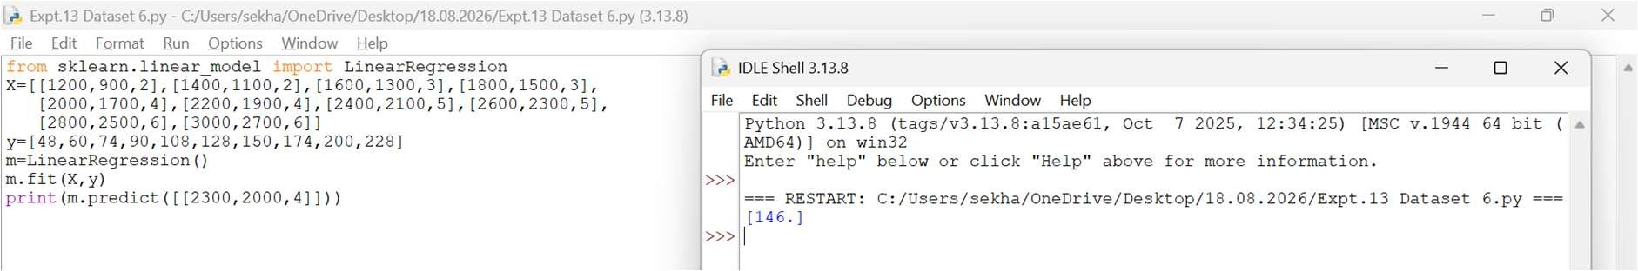
Result
Thus, the Linear Regression model was implemented successfully and the predicted car price is 500000.
EXPERIMENT 14 – HOUSE PRICE PREDICTION
Aim
To predict house prices using the Linear Regression algorithm.
Procedure
- Import the Linear Regression model.
- Create the dataset and target values.
- Train the model using the training data.
- Predict the house price for a new input.
- Display the predicted result.
Code and Output
  - Dataset 1
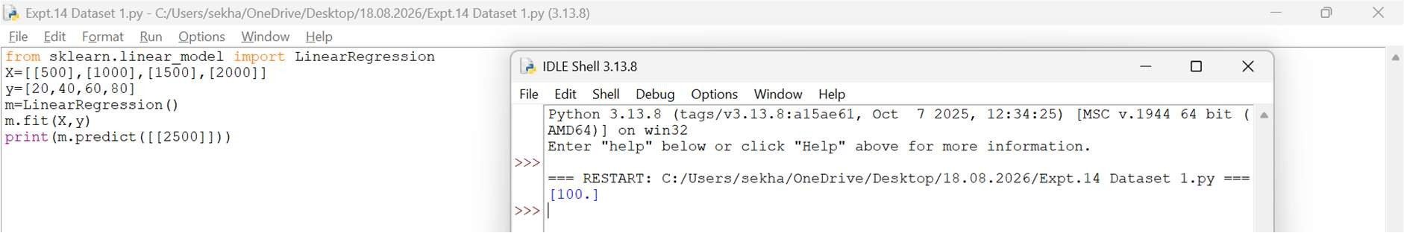
  - Dataset 2
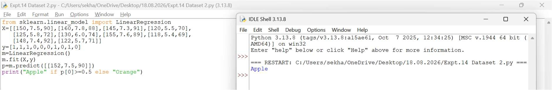
  - Dataset 3
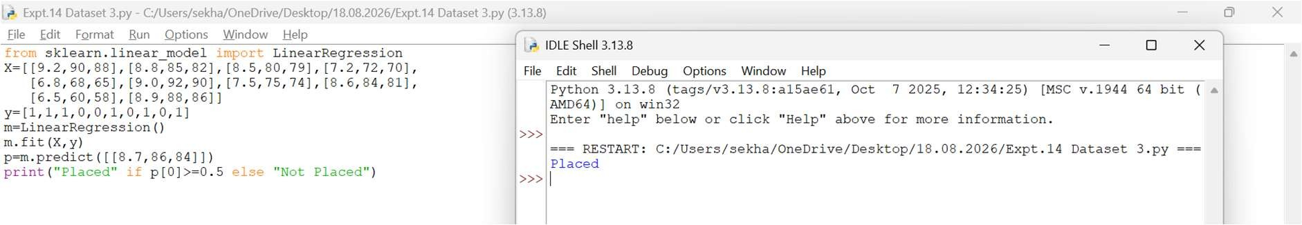
  - Dataset 4
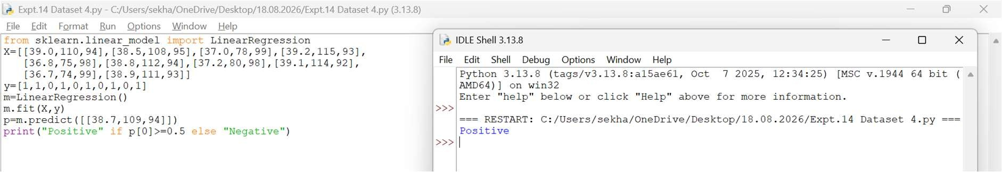
  - Dataset 5
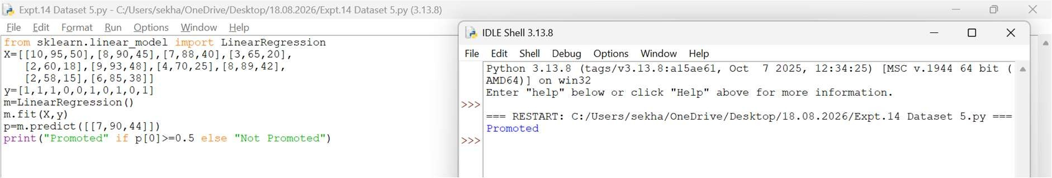
  - Dataset 6
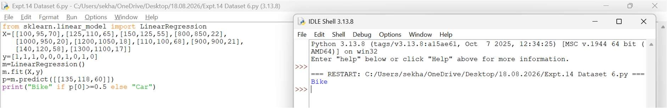
Result
Thus, the Linear Regression model was implemented successfully and the predicted house price is 100.
EXPERIMENT 15 – IRIS FLOWER CLASSIFICATION USING NAÏVE BAYES Aim
To classify Iris flowers using the Naïve Bayes algorithm.
Procedure
- Import the Iris dataset and GaussianNB classifier.
- Load the Iris dataset.
- Train the Naïve Bayes model using the training data.
- Predict the flower class.
- Display the predicted result.
Code and Output
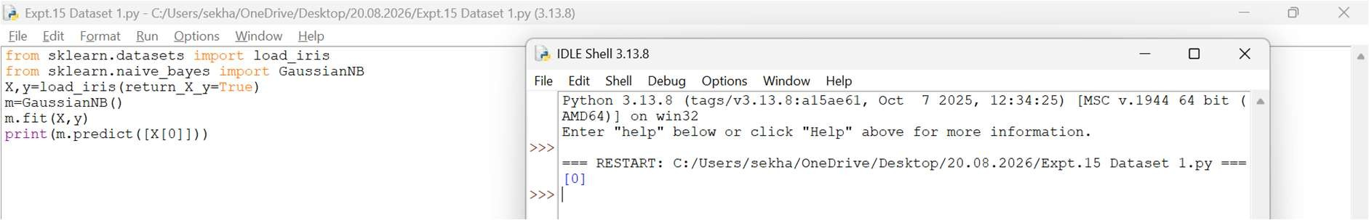
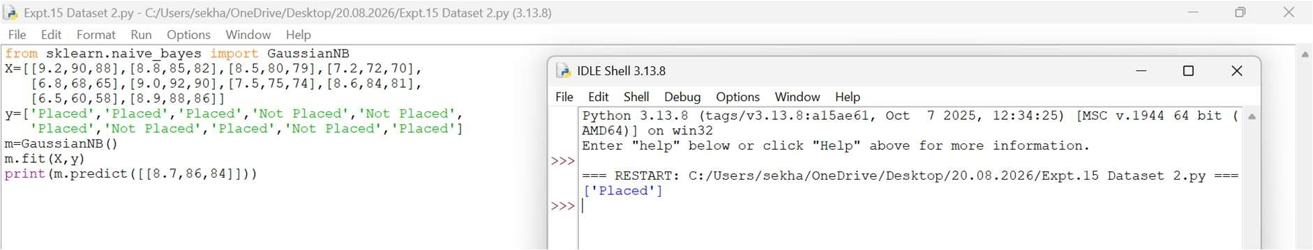
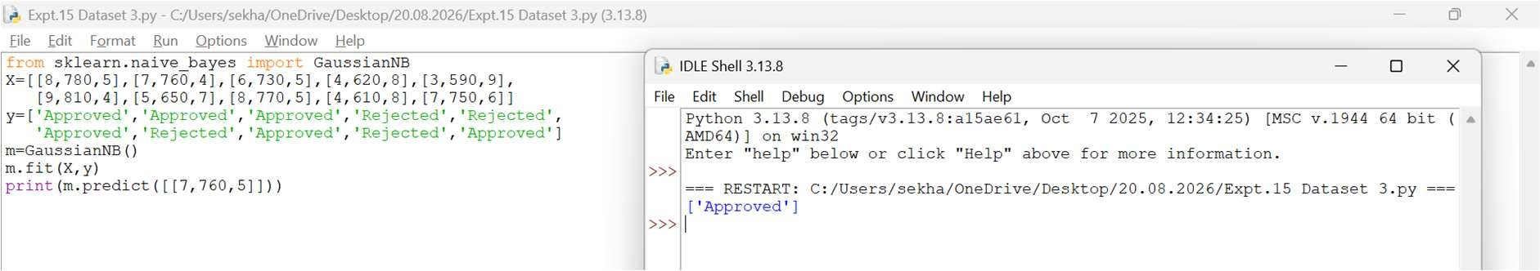
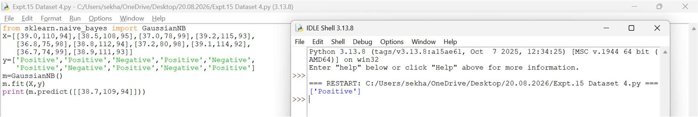
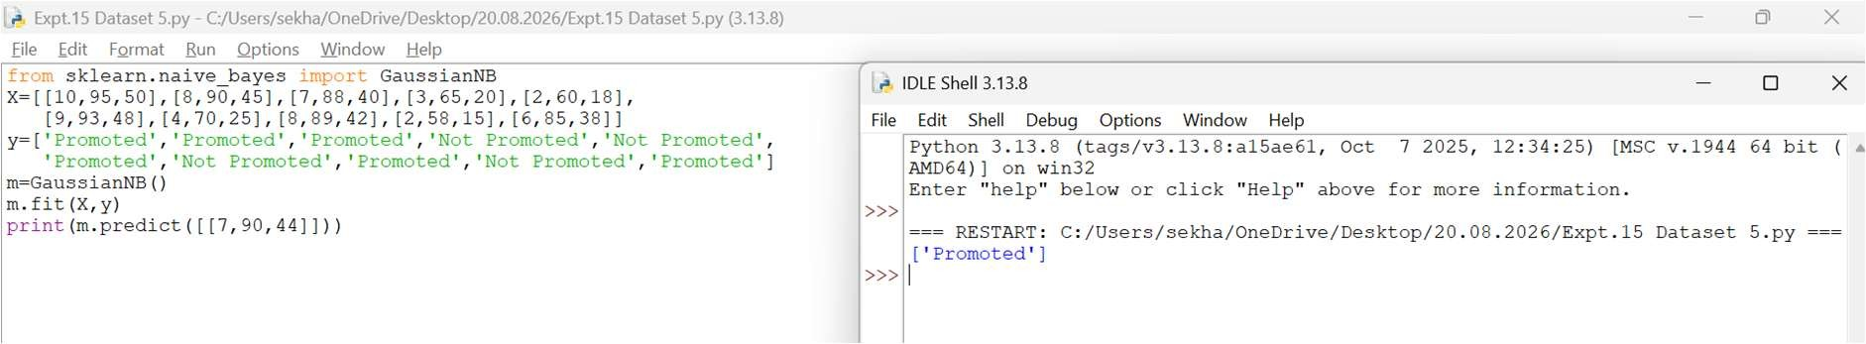
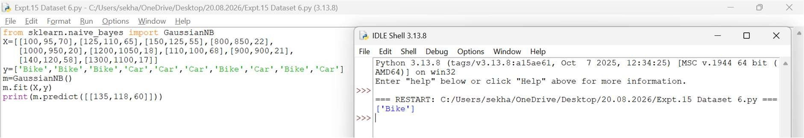
Result
Thus, the Iris flower was classified successfully using the Naïve Bayes algorithm.

EXPERIMENT 16 – COMPARISON OF CLASSIFICATION ALGORITHMS
Aim
To compare the performance of different classification algorithms.
Procedure
- Import the Iris dataset.
- Import Decision Tree and KNN classifiers.
- Train both models using the dataset.
- Calculate the accuracy of each model.
- Compare and display the results.
Code and Output
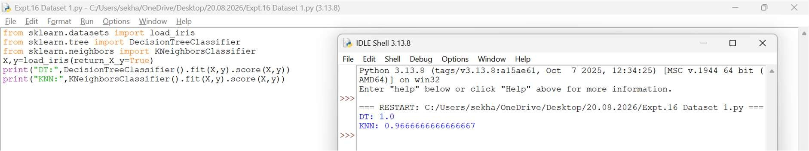
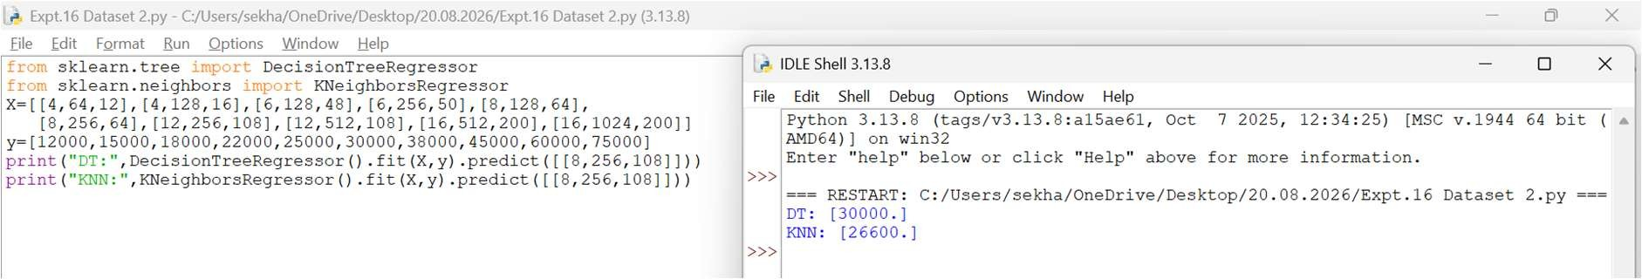
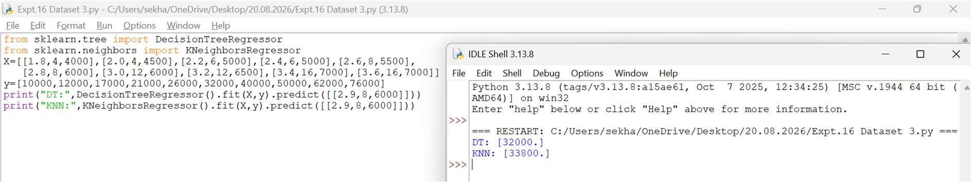
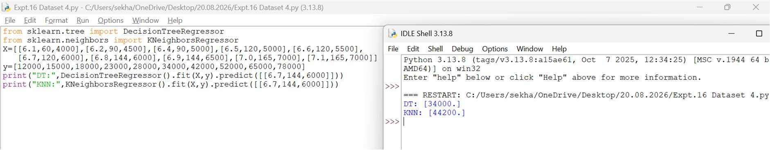
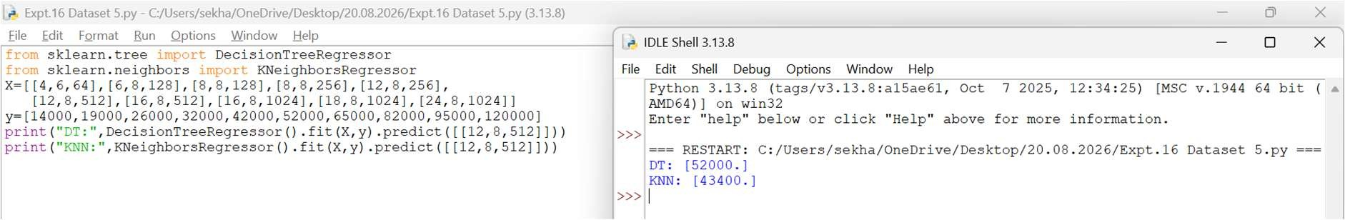
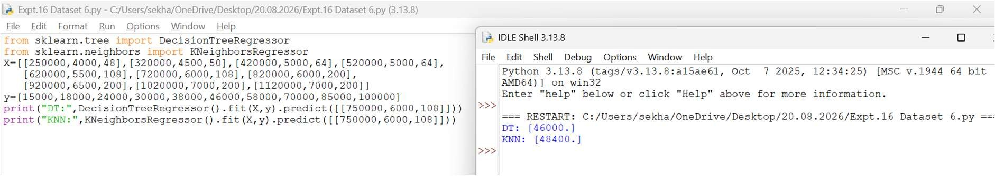
Result
Thus, the performance of Decision Tree and K-Nearest Neighbours (KNN) classifiers was compared successfully. The Decision Tree classifier achieved higher accuracy on the given dataset.
EXPERIMENT 17 – MOBILE PRICE PREDICTION
Aim
To predict mobile prices using the Linear Regression algorithm.
Procedure
- Import the Linear Regression model.
- Create the dataset and target values.
- Train the model using the training data.
- Predict the mobile price for a new input.
- Display the predicted result.
Code and Output
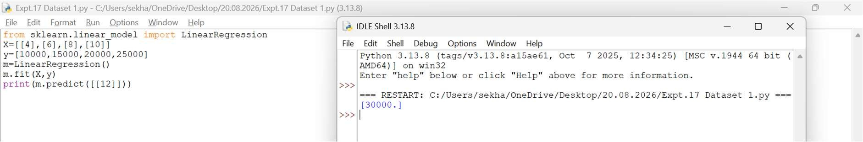
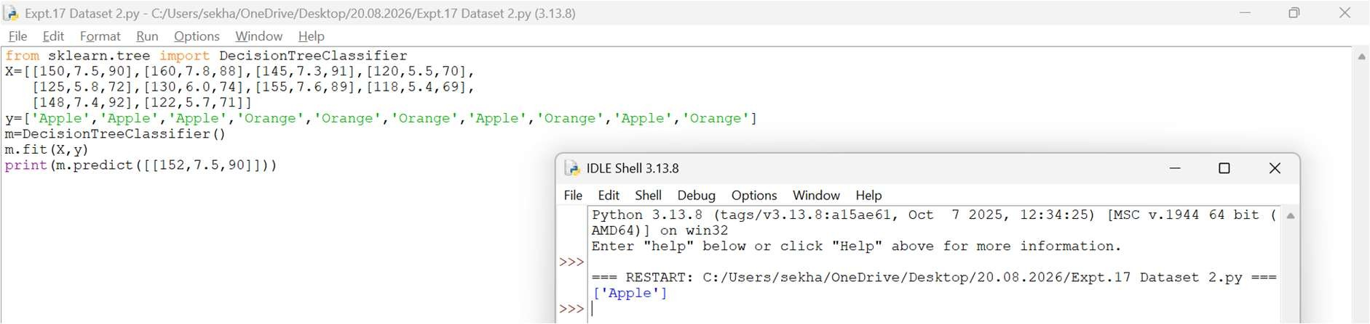
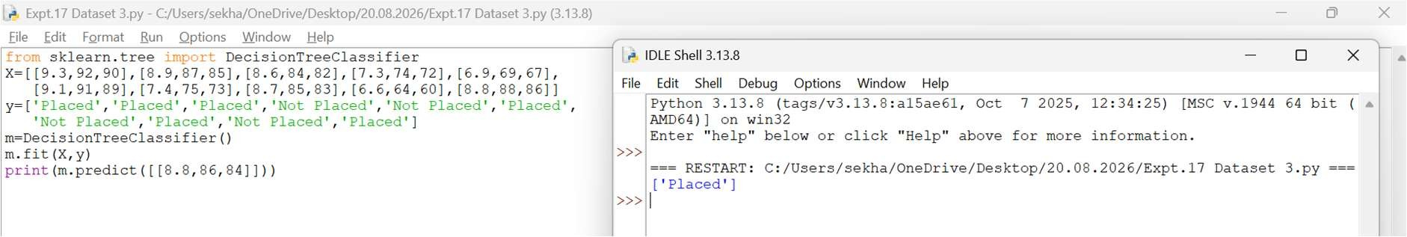
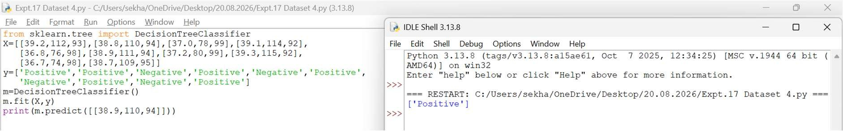
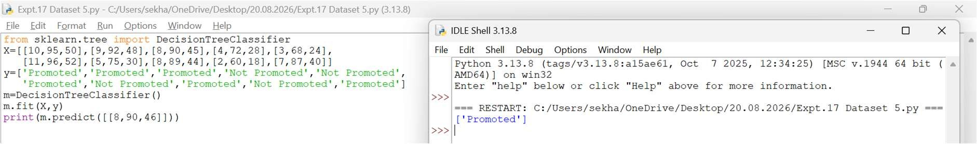
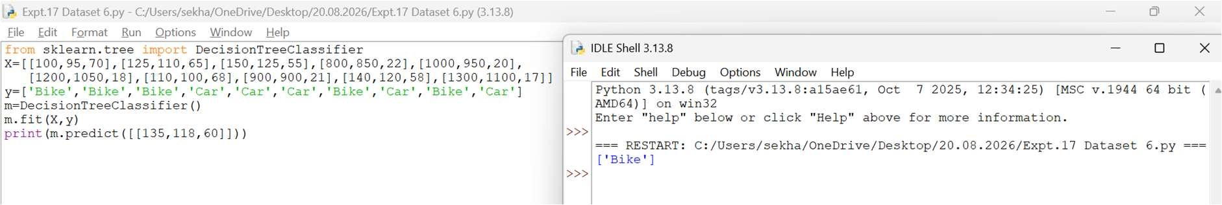
Result
Thus, the Linear Regression model was implemented successfully and the predicted mobile price is 30000.

EXPERIMENT 18 – PERCEPTRON-BASED IRIS CLASSIFICATION
Aim
To classify Iris flowers using the Perceptron algorithm.
Procedure
- Import the Iris dataset and Perceptron classifier.
- Load the Iris dataset.
- Train the Perceptron model using the training data.
- Predict the flower class.
- Display the predicted result.
Code and Output
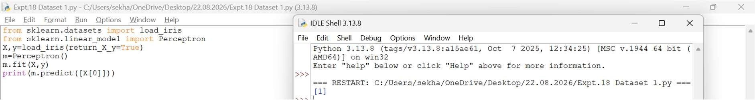
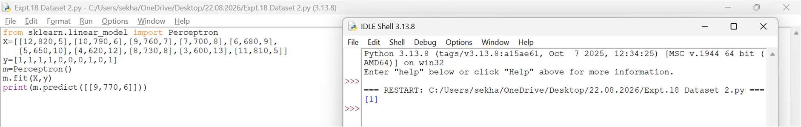
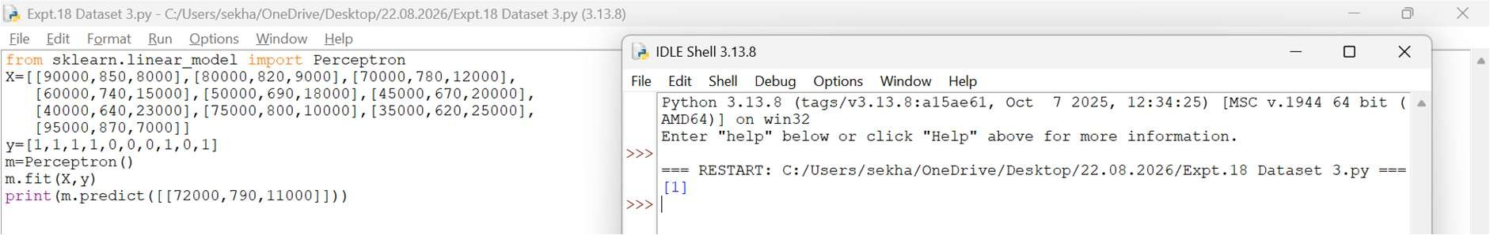
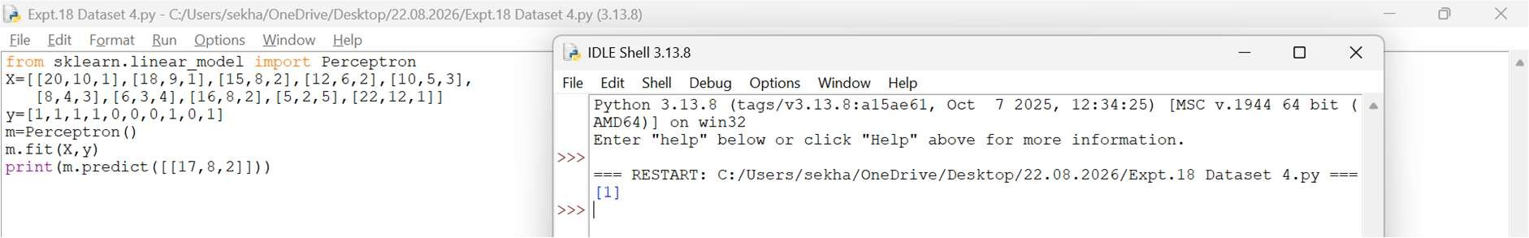
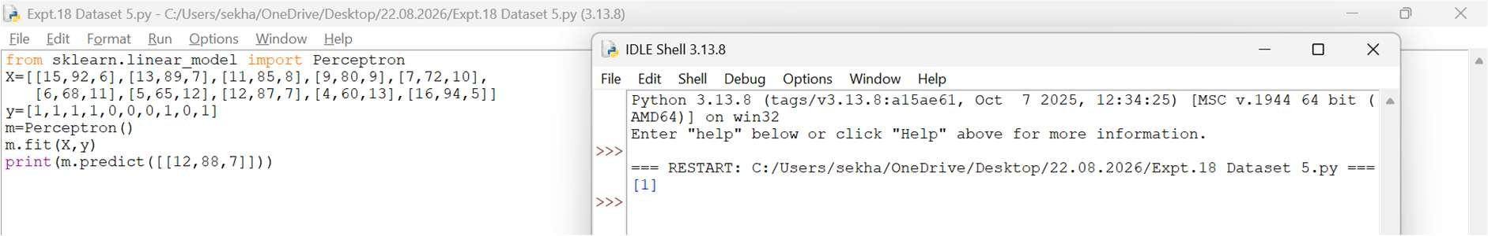
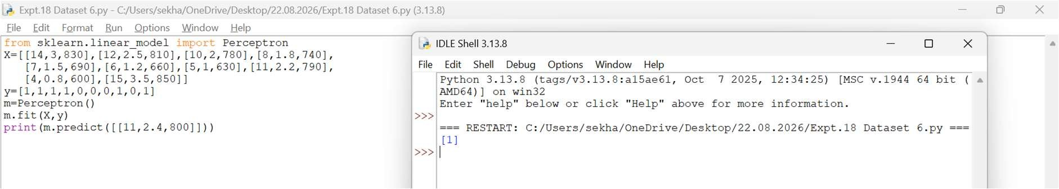
Result
Thus, the Iris flower was classified successfully using the Perceptron algorithm.

EXPERIMENT 19 – BANK LOAN PREDICTION USING NAÏVE BAYES
Aim
To predict bank loan approval using the Naïve Bayes algorithm.
Procedure
- Import the GaussianNB classifier.
- Create the dataset and class labels.
- Train the model using the training data.
- Predict the loan approval status.
- Display the predicted result.
Code and Output
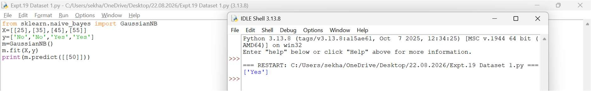
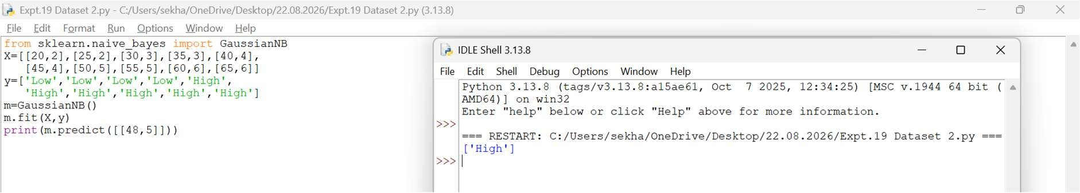
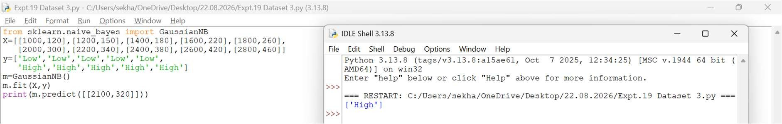
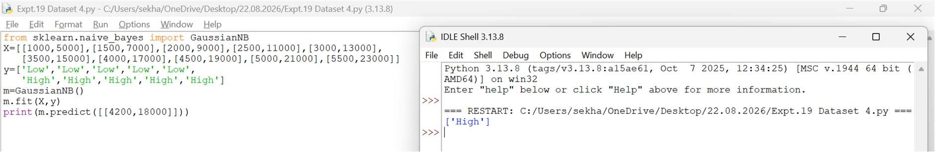
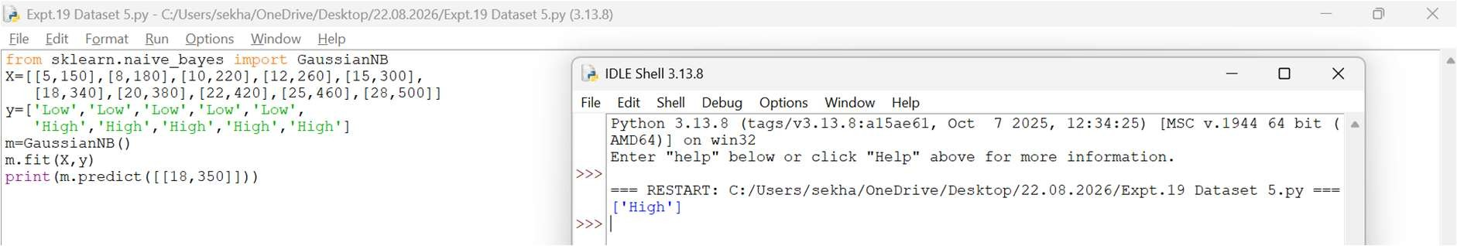
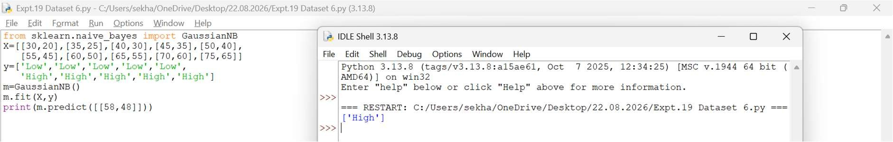
Result
Thus, the Naïve Bayes model was implemented successfully and the loan approval status was predicted as Yes.
EXPERIMENT 20 – FUTURE SALES PREDICTION
Aim
To predict future sales using the Linear Regression algorithm.
Procedure
- Import the Linear Regression model.
- Create the dataset and target values.
- Train the model using the training data.
- Predict future sales for a new input.
- Display the predicted result.
Code and Output
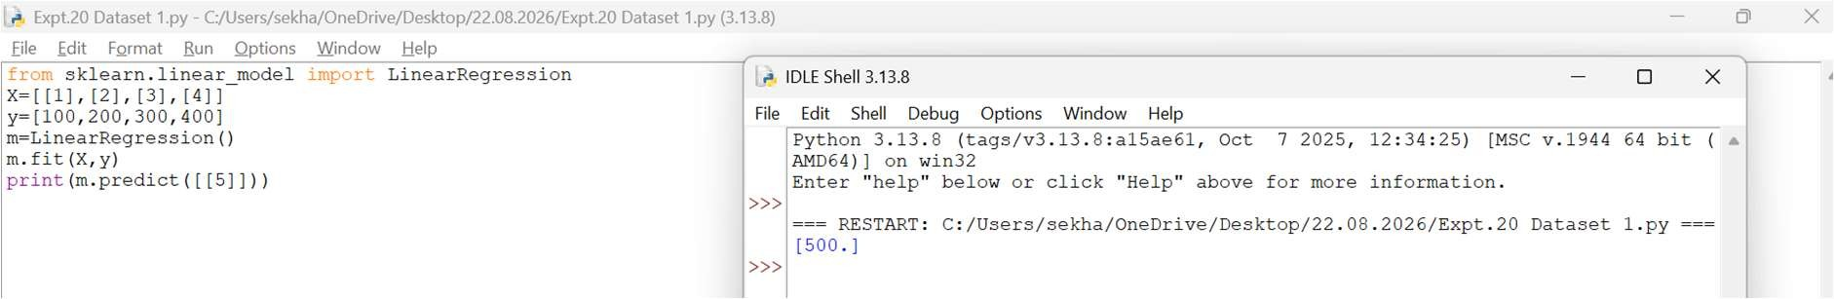
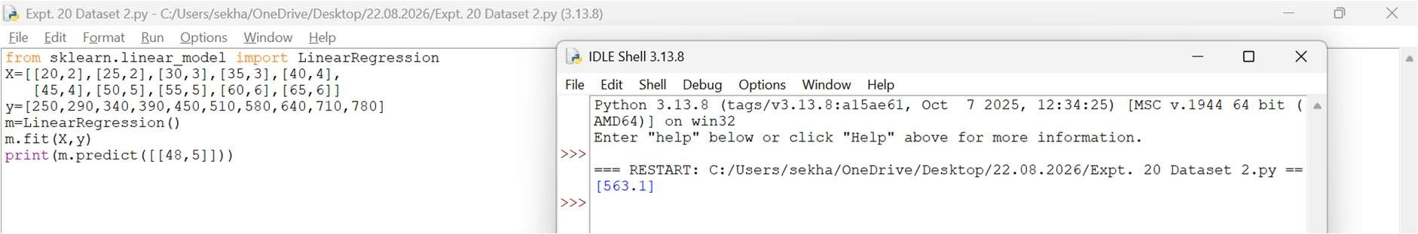
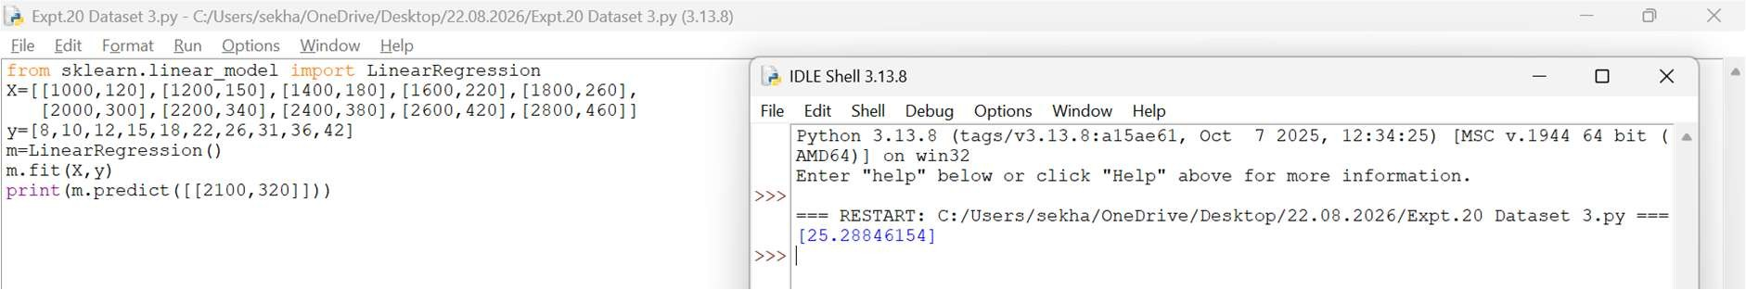
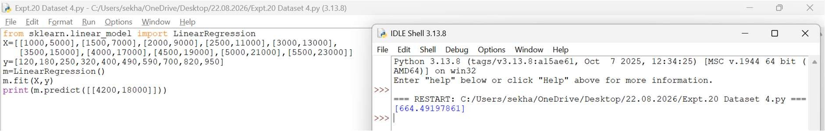
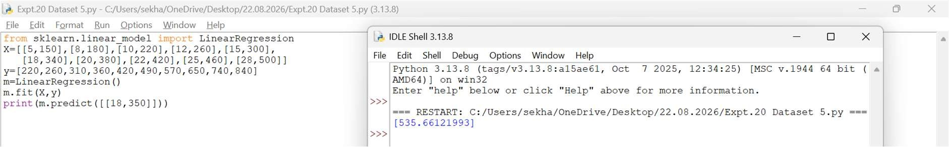
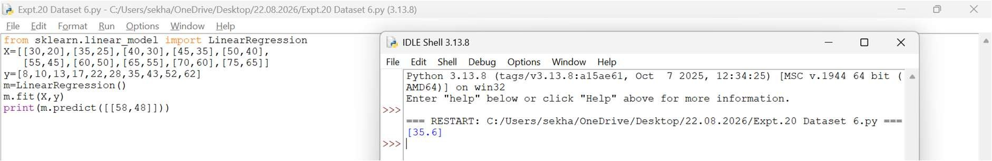
Result
Thus, the Linear Regression model was implemented successfully and the future sales value was predicted as 500.

